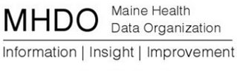

AGENDA

VALUE PROPOSITION SUBCOMMITTEE MEETING

151 Capitol Street, Augusta, Maine

Friday, September 23, 2016

10:00 a.m. - 11:30 a.m.

Instructions to log into the webinar are below

- Review of Agenda and Meeting Goals
- Presentation from Milliman MedInsight: Health Waste Calculator

- Next Steps & Meeting Schedule

- Public Comment

- Adjourn

Audio connection:
1-(866) 913-6864
Conference Code: 604 587 0901
Webinar Connection:
https://milliman.webex.com/milliman/j.php?MTID=mae0b94462835d9389af0924ef0b43488

