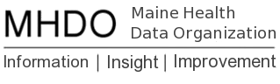

Annual Update Instructions
Last Updated: March 30, 2021

Purpose
The purpose of the upcoming changes and activities in the portal is to:
- Review and update (if necessary) all portal registration information including hospital information, contacts, and users (permissions).
- Evaluate 2021 data against all validation rules by resetting all existing Profile– and Exemption–Level validation rule overrides.

These updates will ensure the accuracy and quality of registration and validation information within the MHDO Hospital Data Portal.

Timelines
Task | Start Date | End Date
Annual validation override reset occurs | 4/6/2021 | 4/6/2021
Annual registration information updates | 4/7/2021 | 4/30/2021
Q1 2021 data file submissions | 4/7/2021 | 6/30/2021

Annual Registration Update Instructions
Action Required from: Administrator Users
- Login. Login to the MHDO Hospital Data Portal between April 7th and April 30th, 2021.
- Review and Update Users
  - One Administrator User from each facility must review and update their facility’s users to complete the 2021 annual registration. Please add, remove, or change permissions for users as appropriate. An explanation of permissions can be found in the User Manual (pages 5-7).
  - Click “Confirm Registration Update 2021 – Users”
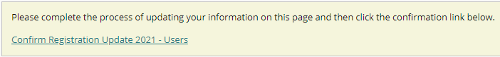
  - Click the Confirm button
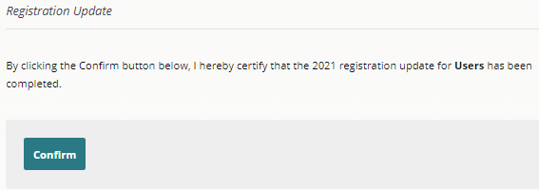
- Review and Update Contacts
  - Each facility must have at least one Administrator and Data Submitter. Accurate information ensures the proper people receive emails from the MHDO Hospital Data Portal and from the MHDO. Each facility must also provide more than one contact person. In addition to the individuals who perform the day to day tasks there should also be backup and management contacts included in the event an issue must be escalated.
  - An explanation of roles can be found in the User Manual (pages 7-9).
  - Click “Confirm Registration Update 2021 - Contacts”
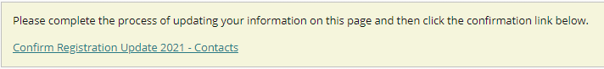
  - Click the Confirm button
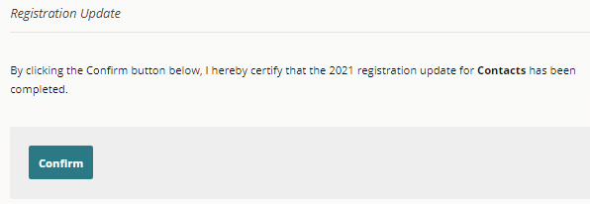
- Review and Update Summary.
  - Please review your facility’s Campus, Campus Sub entities (clinics), and Data Streams. One Administrator User from each company must review and contact the Help Desk (mhdohelp@hsri.org) regarding changes to this information. MHDO Staff will make all edits to information on this page.
  - Click “Confirm Registration Update 2021 - Summary “
  - Click the Confirm button
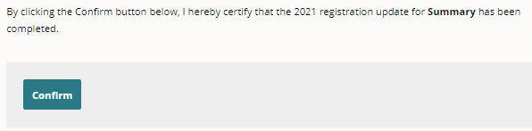
- Completion of 2021 Updates. Once steps 1-4 have been completed successfully a message indicating the 2021 updates are completed will be displayed at the top of the Uses, Contacts, and Summary screens. Please complete these steps by April 30th, 2021. Failure to complete your updates may result in delays processing files and the release of MHDO’s data to authorized data users.
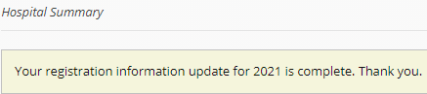

Validation Override Review Instructions
Action Required from: Data Submitters
- Review 2020 Validation Report. Information about how your data performed against the validation rules in the past can be found in the Validation Report. Further instructions for using the report with screen shots can be found in the User Manual (pages 18-19).
- Submit Quarter 1 2021 Data. Submit your Quarter 1 2021 data to the MHDO Hospital Data Portal between April 7th and June 30th, 2021. Note: If you are unable to submit your data by June 30th, these instructions still apply.
- Review and Resolve Validation Issues. Due to all Profile and Exemption-Level overrides being reset, most users will have validation issues to review and resolve. Once you click “Request Override” for a given Profile or Exemption-Level issue you will see a history of past overrides (if there are any), including the reason for the override or termination of the override, for that rule. Further instruction and screenshots can be found in the User Manual (page 16-18).

Validation Rule Updates
We are not making any changes and additions to validation rules at this time.

Help and Reporting Issues
All questions and issues encountered in the portal should be directed to the MHDO Help Desk.
Toll-free Phone: (866) 451-5876
Email: mhdohelp@hsri.org

