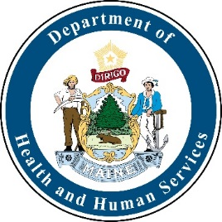
HAI Collaborating Partners Committee

AGENDA
Friday, August 23, 2019
12:00 noon - 4:00 p.m.

Location  Maine Health Care Association  317 State Street  Augusta, Maine | Call-in Information  Join Meeting: https://zoom.us/j/714412121  Mobile call in: (646) 558-8656  Meeting ID: 714 412 121

12:00 – 12:10 pm Introductions and opening comments
Welcome new members and guests
12:10 – 12:20 pm Review of the minutes
12:20 – 1:00 pm Updates:
- Chapter 270
      - Nursing Home Work Group Meeting Sept. 10th
      - Update on the external validation process
1:00 – 2:00 pm Maine HAI/AR State Plan
2:00 – 2:15 pm Break
2:15 – 3:15 pm AR Data
- Antibiogram
- IQVIA
- Milliman
3:40 – 3:50 pm Public comments
3:50 – 3:55 pm Meeting Evaluation
3:55 – 4:00 pm Next meeting and parking lot / adjournment

