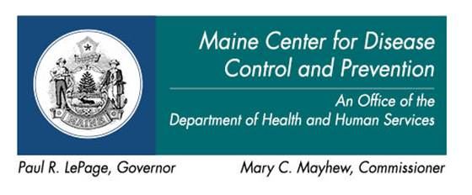

AGENDA

HAI Collaborating Partners Committee

Friday, April 29, 2016  12:00 noon - 4:00 p.m. | Change of location:  MHDO Board Room  151 Capitol Street  Augusta, Maine  Or call: 877-826-6967, Conf. code 1780250
12:00 – 12:10 pm Introductions and Opening Comments
12:10 – 12:15 pm Minutes of the last meeting
12:15 – 1:00 pm Review the 2016 Maine HAI Annual Report and the U.S.
CDC's 2016 HAI Progress Report
1:00 – 1:30 pm Review recent "clean-up" updates to Chapter 270
1:30 – 2:30 pm Discuss possible substantive changes to Chapter 270 for 2017
- Acute Care
- Long Term Care
- Committee recommendations
2:30 – 3:00 pm Update on the HAI training module for LTC facilities
3:00 – 3:30 pm QIN-QIO collaborative for Long Term Care/Nursing Facilities
3:30 – 3:45 pm Public Comments
3:45 – 4:00 pm Meeting Evaluation/Adjournment

Meeting Materials:
2016 HAI Annual Report
https://mhdo.maine.gov/_externalReports/2016%20HAI%20Annual%20Report_Final%202016-03-31.pdf
2016 U.S. CDC National and State Healthcare Associated Infections Progress Report
http://www.cdc.gov/HAI/pdfs/progress-report/hai-progress-report.pdf
2016 "Clean-up" updates to Rule Chapter 270 (see accompanying email):
- Basis statement for changes to the Rule
- Provisionally adopted version of Rule Chapter 270
Samples from the HAI training model for LTC facilities (see accompanying email)
CSTE position statement on HAI surveillance in long term care
http://c.ymcdn.com/sites/www.cste.org/resource/resmgr/2015PS/2015PSFinal/15-ID-04.pdf

