DRAFT

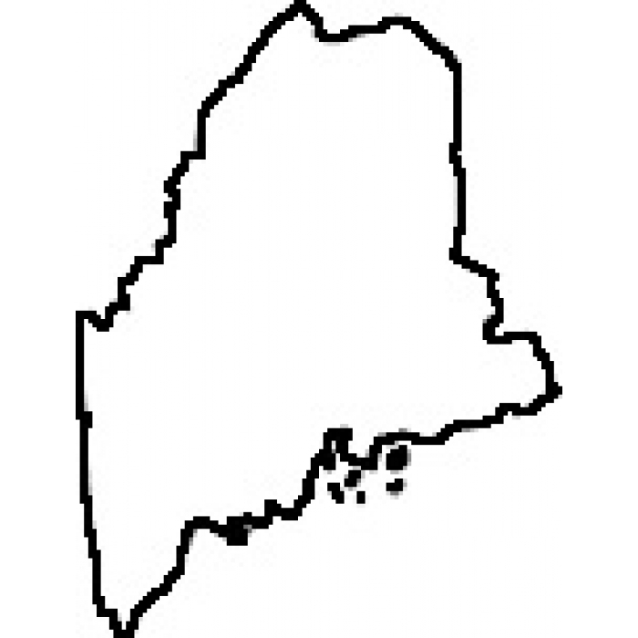
State of Maine
Healthcare Associated Infections Plan
2015-2018

Department of Health and Human Services
Maine Center for Disease Control and Prevention
Division of Infectious Disease
Introduction:
Healthcare-associated infections (HAIs) are infections caused by a wide variety of common and unusual bacteria, fungi, and viruses during the course of receiving medical care. Medical advances have brought lifesaving care to patients in need, yet many of those advances come with a risk of acquiring an HAI. These infections related to medical care can be devastating and even deadly.

On any given day, about one in twenty-five hospital patients have at least one HAI. There were an estimated 722,000 HAIs in the United States acute care hospitals in 2011. About 75,000 hospital patients with HAIs died during their hospitalization¹. As our ability to prevent HAIs grows, these infections are increasingly unacceptable.

Additionally, treatment for HAIs and other infections is becoming more challenging as antibiotic resistance is increasing. Several bacteria have gained the ability to generate enzymes that destroy antibiotics or can change their cell wall structure to block antibiotics. In these cases, antibiotic choices for treatment are becoming increasingly limited, expensive, and in some cases, nonexistent.

Each year in the United States, at least 2 million people have an infection associated with bacteria that are resistant to antibiotics and at least 23,000 people die each year because of these infections². Antibiotic-resistant infections can happen anywhere. Data show that most happen in the general community; however, most deaths related to antibiotic resistance happen in inpatient healthcare settings, such as hospitals and nursing homes. Antibiotic resistance (AR) is one of the most pressing threats facing the world today².
The road to eliminating HAIs and combating antibiotic resistance is a road traveled by many. National leadership is issuing guidance in the form of action plans. Goals are established and annual reports monitor progress.
- Action plans:
  - National Action Plan to Prevent Health Care-Associated Infections: Road Map to Elimination. April 2013. (U.S. Department of Health and Human Services)
  - National Action Plan for Combating Antibiotic Resistant Bacteria. March 2015. (U.S. Government)
- Goals: Healthy People 2020. December 2010. (CDC)
- Progress Reports: HAI Progress Report. Annual Report. (CDC)

The state of Maine has an important role in this national movement. Numerous organizations across the state as well as healthcare facilities in the acute care, extended care, and ambulatory care settings are working hard to eliminate HAIs and combat antibiotic resistance. Maine’s HAI Plan is our state’s action plan for this work over the next three years. It focuses on three primary actions,
- RESPOND to threats of infectious disease transmission,
- ANALYZE data to target prevention activities and
- PREVENT future HAIs and antibiotic resistance through education and training, promoting best practices through group collaborative programs and expanding antimicrobial stewardship efforts.

A summary of activities and outcomes will be available each year in the annual State HAI Report.

¹Magill SS, Edwards JR, Bamberg W, et al. Multistate Point-Prevalence Survey of Health Care–Associated Infections. N Engl J Med 2014;370:1198-208.
²Centers for Disease Control and Prevention. Antibiotic/Antimicrobial Resistance website.: http://www.cdc.gov/drugresistance.

Acronyms:

AR Antibiotic Resistance
CAUTI Catheter-Associated Urinary Tract Infection
CDC federal Centers for Disease Control and Prevention
CDI Clostridium difficile Infection
CEO Chief Executive Officer
CLABSI Central Line-Associated Blood Stream Infection
CRE Carbapenem-Resistant Enterobacteriaceae
DART Data Analysis by Region for Trends Program
DHHS Department of Health and Human Services
DNA Deoxyribonucleic acid
HAI Healthcare Associated Infection
HETL Health and Environmental Testing Laboratory
ICAP Infection Control Assessment and Promotion Program
Maine CDC Maine Center for Disease Control & Prevention
MDRO Multidrug-Resistant Organism
MHA Maine Hospital Association
MHDO Maine Health Data Organization
MICIS Maine Independent Clinical Information Service
MQF Maine Quality Forum
MRSA Methicillin-Resistant Staphylococcus aureus
NHSN National Healthcare Safety Network
PTC-APIC Pine Tree Chapter – Association for Professionals in Infection Control and Epidemiology
QIN-QIO Quality Innovation Network – Quality Improvement Organization
VAE Ventilator-Associated Event
VISA Vancomycin-Intermediate resistant Staphylococcus aureus
VRE Vancomycin-Resistant Enterococcus

Purpose
Eliminate healthcare associated infections and combat antibiotic resistance
RESPOND
Detect, investigate, control and prevent HAI-related outbreaks
Ensure preparedness for emerging pathogens, especially those needing enhanced precautions

PREVENT
Provide education, training and consultative services
Engage in infection prevention activities
Expand antimicrobial stewardship efforts

ANALYZE
Prioritize HAI data for statewide surveillance
Ensure quality of data
Ensure surveillance data is available to key stakeholders
Increased data analysis

RESPOND
Priorities | Year 0 (2015) | Year 1 (2016) | Year 2 (2017) | Year 3 (2018)
Detect, investigate, control and prevent  HAI-related outbreaks | Define HAI Outbreak for state of Maine, based on federal CDC epidemiological definitions.  Design and implement a system to track HAI outbreak response and outcomes, for outbreaks reported to public health. | Assess capacities of healthcare facilities to detect, report and respond to potential outbreaks and emerging threats, using standardized tool (from federal CDC).  Determine gaps in HAI outbreak reporting and response in all healthcare settings | Address gaps in outbreak investigation capacity by working with healthcare partners to develop a plan (and infrastructure) to improve outbreak reporting and response. | Explore public reporting of outbreak, considering the balance between public reporting without creating unintended harm and which outbreaks are ‘worth’ of public reporting, in real-time.
 |  | Explore the need for additional laws related to state authority for public health to conduct investigations related to HAI outbreaks and lapses in infection prevention and control. | Explore communication plans among healthcare facilities to minimize the risk of transmission of infectious disease and/or outbreak.
Ensure preparedness for emerging pathogens, especially those needing enhanced precautions | Assess Ebola readiness at all four Ebola-assessment hospitals in the state. DHHS to work collaboratively with these selected healthcare facilities to address any remaining gaps in readiness in order to achieve “capacity met” status in each of eleven domains of preparedness.  Conduct webinar with hospitals to share findings. | Explore state level emerging pathogen drill and/or table top exercise at HAI conference.
 | CRE should become a ‘Notifiable Conditions’ by the fall of 2015. All cases of CRE would be reportable to Maine CDC for epidemiological study. | Analyze initial data from CRE as a Notifiable Condition in the state. Based on first year findings, determine the need for additional guidance for control of CRE beyond the federal CDC 2012 CRE Toolkit. | Include CRE data in the Reportable Infectious Diseases in Maine annual summary report (include genotypic data in analysis).

ANALYZE
Priorities | Year 0 (2015) | Year 1 (2016) | Year 2 (2017) | Year 3 (2018)
Prioritize HAI data for statewide surveillance | Review and revise state mandated HAI reporting requirements (Chapter 270). | Explore surveillance for LTC facilities, targeting MDROs, antibiotic usage, use of MHDO vs. NHSN for reporting.
Ensure quality of HAI data | Conduct validation for all NHSN reportable data on a rotating schedule.
Ensure surveillance data is available to key stakeholders | Legislature and Public: State HAI Annual Report issued by MHDO/MQF.
 | Public: Comparisons of acute care hospital cost, patient satisfaction, and HAI data provided through Compare Maine
 | Healthcare Facilities: Facility and region (6 New England states) reports for facilities in QIN-QIO collaborative programs.
Acute Care: CEO Dashboard Reports issued annually by Maine CDC; facility specific trend of HAI and prevention data.
(to be expanded to other facilities types as they come on board with HAI reporting)
 | The Maine Hospital Association (MHA) Board of Directors: Regularly reviewing hospital specific and statewide C. difficile and MRSA data obtained from the Maine CDC/MHDO.
Increase data analysis | Develop and implement the Data Analysis by Region for Trends (DART) Program.  - Create an inventory of all healthcare settings in the state. Include at least one infection control point of contact at each facility, identify current regulatory/licensing authority for each healthcare facility and explore ways to expand oversight.  - Build capacity to analyze data reported by facilities in a defined region to allow for comprehensive assessment of potential HAI threat, and communicate results with healthcare facilities  - Work with federal CDC to guide analytic direction and identify facilities for prioritized assessment/response.  - Implement a response plan to address potential emerging threats identified by using enhanced surveillance.

PREVENT
Priorities | Year 0 (2015) | Year 1 (2016) | Year 2 (2017) | Year 3 (2018)
Provide education and training | Acute Care: Education webinars targeting CLABSI, CAUTI, CDI, VAE prevention (QIN-QIO).  Acute Care: Ebola preparedness training (federal CDC) | Build resource list or library of various educational tools, presentations, etc. that have been created. Share repository with healthcare facilities in state. | Promote patient education ‘What you can do to help prevent infection’. Explore public service announcement, Facebook, twitter, radio spots, newspaper, website, etc.
 | Offer Infection Preventionist mentorship program (PTC-APIC)
 |  | Explore logistics of holding a bi-annual HAI prevention conference in 2016 or 2017. Explore partnership to host conference with PTIC-APIC and/or the six New England states.
Explore requiring Infection Prevention and Control staffing capacity levels.

Explore requiring infection control and prevention competency as part of licensing or credentialing for providers.
Engage in infection prevention activities. |  | Develop and implement Infection Control Assessment and Promotion (ICAP) Program.  - Based on data from the DART Program, perform targeted assessments in infection prevention and control at healthcare facilities.  - Identify gaps and work through the HAI advisory council for state/region mitigation planning.
Acute Care
Collaborative programs hosted by Healthcentric Advisors [QIN-QIO], to reduce HAIs related to CLABSI, CAUTI, CDI, and VAE.

Expand antimicrobial stewardship efforts | MICIS – details pending | Engage HAI advisory council in developing state action plan for improving antibiotic usage in state.  - Begin with survey of healthcare facilities AMS surveillance programs.  - Explore impact of antibiotic shortage issues on AMS recommendations.
Promote Get Smart About Antibiotics Week (November) through
public service announcements, groups talks, etc.
 |  | State public health laboratory (HETL) to roll out study with clinical laboratories to conduct DNA analysis on isolates of multidrug resistant organisms (e.g. MRSA, VRE, CRE and VISA) in order to determine the resistance genes most frequently seen in Maine. The next class of antibiotics will target these resistance genes in bacteria. Share the findings with providers.

Department of Health and Human Services
Maine Center for Disease Control and Prevention
State House Station #11
Augusta, ME 04333-0011

Paul R. LePage
Governor

Mary C. Mayhew
Commissioner

Kenneth Albert, RN, Esq.
Director and Chief Operations Officer
Maine Center for Disease Control and Prevention

The Department of Health and Human Services (DHHS) does not discriminate on the basis of disability, race, color, creed, gender, age, sexual orientation, or national origin, in admission to, access to or operation of its programs, services, activities, or its hiring or employment practices. This notice is provided as required by Title II of the Americans with Disabilities Act of 1990 and in accordance with the Civil Rights Acts of 1964 as amended. Section 504 of the Rehabilitation Act of 1973 as amended, the Age Discrimination Act of 1975, Title IX of the Education Amendments of 1972 and the Maine Human Rights Act. Questions, concerns, complaints, or requests for additional information regarding civil rights may be forwarded to the DHHS’ ADA Compliance/EEO Coordinator, State House Station #11, Augusta, Maine 04333, 207-287-4289 (V) or 207-287-3488 (V), TTY: 800-606-0215. Individuals who need auxiliary aids for effective communication in programs and services of DHHS are invited to make their needs and preferences known to the ADA Compliance/EEO Coordinator. This notice is available in alternate formats, upon request.

