MHDO APCD Business Rules and Entity Relationship Diagrams (ERDs)
Last Updated: 1/8/2019

Introduction
This document is designed to provide background on MHDO’s APCD Business Rules and entity relationship diagrams for current and potential data users. This Business Rules were developed to describe the current methodology used to derive the value-added components of the MHDO APCD. The entity relationship diagrams (ERDs) were developed to show the relationships between data tables. This documentation will evolve over time as we continue to enhance the MHDO Data Warehouse and APCD capabilities. This will include the development of analysis ready datasets and the inclusion of more value adds (groupers).

Business Rules
The following describes the methodology used to derive the value-added components of the MHDO APCD.

Age
In the claims data, the age fields (MC901_AGE, PC901_AGE, DC901_AGE) are calculated based on date of service date (MC059_FDATE, DC035_FDATE) and member’s date of birth (MC013_DOB, PC013_DOB, DC014_DOB) or filled date (PC032_FDATE). In the eligibility data, the age fields (ME901_AGE, PE901_AGE, DE901_AGE) are calculated based on the fifteenth day of the eligibility month (ME005_MONTH, PE005_MONTH, DE005_MONTH) and the member’s date of birth (ME014_DOB, PE014_DOB, DE014_DOB).
The rule of top coding applies to patients ages 90 or older. A person that is 90 years old at date of service will have the age field set to value ‘90’ and the date of birth field set to missing. A person that is 91 years old or older at admission will have the age field set to value ‘90’ and the date of birth field set to missing.

MHDO Assigned Member Number
When data are available, the system calculates multiple Member Numbers for each record. These will be:
- MemberNum_SUBSSN: This is created from the Subscriber SSN, the Member DOB and the Member Gender
- MemberNum_Contract: This is created from the Contract Number, the Member DOB, and the Member Gender
- MemberNum_MEMSSN: This is created from the Member SSN, the Member DOB, and the Member Gender
When the MemberNum_SUBSSN is available, it is considered the canonical Member Number and is used as the release Member Number. If it is not available, the other Member Numbers are used as lookup keys to attempt to find the MemberNum_SUBSSN that is associated with a given Member Number_Contract or MemberNum_MEMSSN (search is performed in the order specified). If found, the associated MemberNum_SUBSSN is used as the release Member Number. If no match is found, one of the other Member Numbers is then be used as the release Member Number. The only circumstance where no release Member Number is provided is when there was no Subscriber SSN, Contract Number, Member SSN, Member DOB, or Member Gender available.
There are some payers with known issues linking their claims and eligibility member identifiers. For these payers, alternate logic is used so that the member ID chosen is consistent between the claims and eligibility whenever possible.

Integer Substitution of Identifiers
In order to reduce the size of data files and to enhance security, the MHDO performs “integer substitution” on certain fields. The process replaces the underlying value with a unique integer. The integer is not derived from the contents of the field, meaning that there is no way for data users to decode the integer into the original field value. However, every instance of a given field value will always be assigned the same integer, allowing for matching between records.
Integer substitution is performed on the payer’s claim ID, social security numbers, contract numbers, and MHDO-Assigned Member Numbers.

Medical Claim Consolidation Table
Based on feedback from MHDO data users we have developed and are releasing "Claim Consolidation" information for medical. This involves providing information on which claim lines should be included to form "the final version" of the claim. Delivering this level of information will allow data users to more quickly exclude claim lines that have been reversed or reissued.
MaineCare and commercial payers occasionally issue adjustments or reversals to previously paid medical claims. Past analysis has shown that adjustments happen with less than 3% of the commercial claims and the claims that get reversed are more likely to get reversed multiple times. According to MHDO Rule Chapter 243 and the ASC X12 837 standard each version of the claim should be fully reversed before new claim lines are issued. However, of the top five commercial payers which represent approximately 80% of the commercial claims data, the MHDO is aware of one that is not able to do this. Aetna has provided the MHDO with their custom versioning logic which allows the MHDO to determine the final version of the claim in these cases. When there is payer-specific logic, MHDO will use it instead of the standard versioning method. By default, however, the version of the claim with the latest paid date will be considered the final version of the claim. The logic takes into account claim line-level information such as member, service date, and procedure codes to attempt to detect reversals that are issued under different claim numbers.
In some cases, the most recent version of a claim will be the reversal and the reissue of the new claim lines may have been issued under a new claim number. In these cases, the original claim will include both the initial bill and a set of reversals essentially "zeroing out" the claim.
So, for instance, claim 15434324 may have had an initial bill (IDNs 8841231-8841233), a reversal (IDNs 9268232-9268234), and a newly issued bill (IDNs 9854741-9854743). In this case, only the claim lines from the newly issued bill should be used.

Claim Consolidation Table Example
MC907_MHDO_Claim | MC902_IDN
15434324 | 9854741
15434324 | 9854742
15434324 | 9854743
15434325 | 56849847
15434325 | 56849848
15434325 | 56849849

In the above example, claim detail lines associated with two claims are shown: 15434324 and 15434325. Each of these claims has three claim detail lines associated with it. Performing an inner join of this table to the medical claims detail table on the MC902_IDN field will restrict the detail to only detail lines that in the final version of the claim.
As the MHDO receives new data, the set of "final claim lines" may change for a claim. The MHDO will distribute a full refresh of the Claim Consolidation table with every data release. This table should cover the full date range of your data request, including IDNs for both newly distributed data and data that have been previously sent. Users making use of this table will need to perform an inner join with the with the medical claims detail table with each data release since reversal activity can continue long after the initial payment of the claim, especially for high-dollar claims. As MHDO becomes aware of payer-specific issues that prevent the standard logic from operating correct, the MHDO will work with payers to implement custom consolidation logic.

Insurance Product Type Codes
The classification authority for claim product types and eligibility product types differ in Chapter 243, although the two sources use some of the same code values. In an effort to avoid confusion, the MHDO has historically recoded 4 of the most common claim product types (12, 13, 15, and 16) submitted in MC003 to use values that match the semantics of the eligibility (PR, PS, IN, and HN, respectively). This recoding is performed and released in MC913_MHDO_PRODUCT.

Entity Relationship Diagrams (ERDs)

Key
Primary Key
Foreign Key

Definitions
Primary Key: A primary key is a field (or collection of fields) in a table that uniquely identifies a row on that table.
Related Table: A table that contains data that can be linked to a particular table in question.
Foreign Key: A foreign key is a field (or collection of fields) in a table that uniquely links to a primary key in a related table.
Multiplicity Indicators: 0..1 means “zero to one” and 0...* means “zero or more”

Medical Claims

Diagram
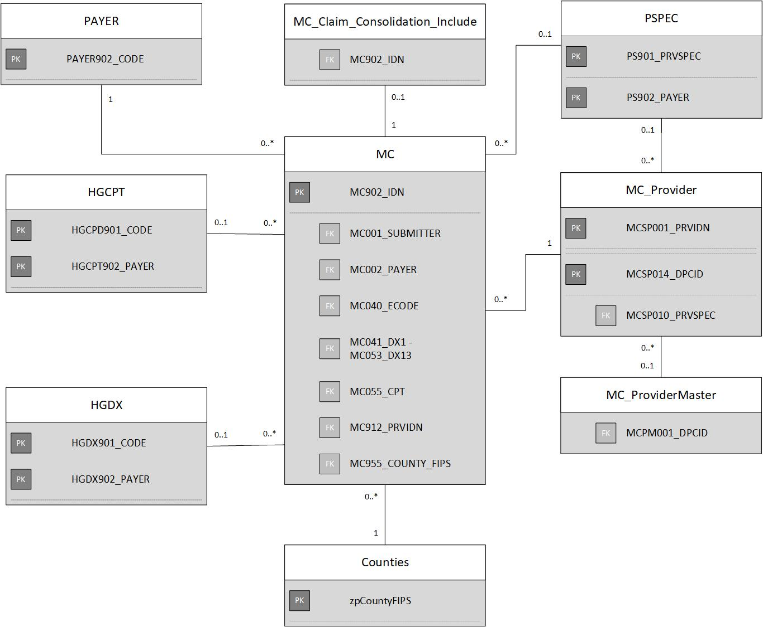

Support Table
Table Name | Table Description | Primary Key | Related Table Name | Related Table Description | Foreign Key
PAYER | Payer Code Support Table | PAYER902_CODE | MC | Medical Claims Release Table | MC001_SUBMITTER, MC002_PAYER
MC_Claim_Consolidation_Include | Medical Claims Consolidation Support Table | MC902_IDN | MC | Medical Claims Release Table | MC902_IDN
PSPEC | Payer Assigned Specialty Codes Support Table | PS902_PAYER | MC | Medical Claims Release Table | MC001_SUBMITTER
 |  | PS901_PRVSPEC | MC_Provider | Medical Claims Service Provider Support Table | MCSP010_PRVSPEC
MC_Provider | Medical Claims Service Provider Support Table | MCSP001_PRVIDN | MC | Medical Claims Release Table | MC912_PRVIDN
 |  | MCSP014_DPCID | MC_ ProviderMaster | Medical Claims Provider Master Support Table | MCPM001_DPCID
Counties | Counties Support Table | zpCountyFIPS | MC | Medical Claims Release Table | MC955_COUNTY_FIPS
HGDX | Local Diagnosis Codes Support Table | HGDX901_CODE | MC  (link to only one of the fields to the right) | Medical Claims Release Table | MC040_ECODE
 |  |  |  |  | MC041_DX1
 |  |  |  |  | MC042_DX2
 |  |  |  |  | MC043_DX3
 |  |  |  |  | MC044_DX4
 |  |  |  |  | MC045_DX5
 |  |  |  |  | MC046_DX6
 |  |  |  |  | MC047_DX7
 |  |  |  |  | MC048_DX8
 |  |  |  |  | MC049_DX9
 |  |  |  |  | MC050_DX10
 |  |  |  |  | MC051_DX11
 |  |  |  |  | MC052_DX12
 |  |  |  |  | MC053_DX13
 |  | HGDX902_PAYER | MC | Medical Claims Release Table | MC001_SUBMITTER
HGCPT | Local Procedure Codes Support Table | HGCPT901_CODE | MC | Medical Claims Release Table | MC055_CPT
 |  | HGCPT902_PAYER | MC | Medical Claims Release Table | MC001_SUBMITTER

Pharmacy Claims

Diagram
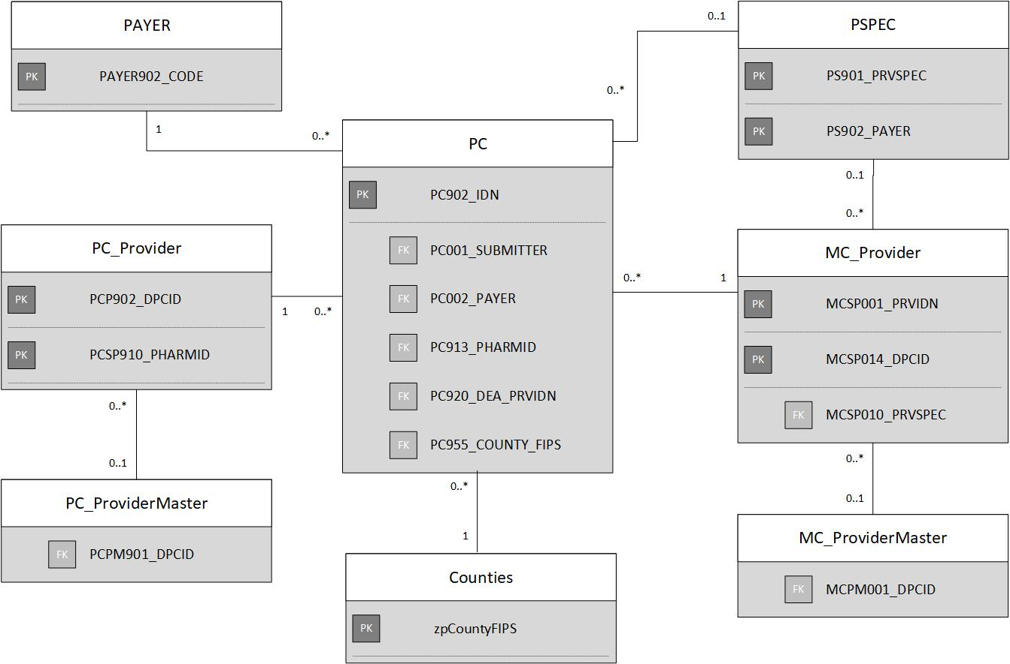

Support Table
Table | Table Description | Primary Key | Related Table Name | Related Table Description | Related Key
PAYER | Payer Code Support Table | PAYER902_CODE | PC | Pharmacy Claims Release Table | PC001_SUBMITTER,  PC002_PAYER
PSPEC | Payer Assigned Specialty Codes Support Table | PS902_PAYER | PC | Pharmacy Claims Release Table | PC001_SUBMITTER
 |  | PS901_PRVSPEC | MC_Provider | Medical Claims Service Provider Support Table | MCSP010_PRVSPEC
MC_Provider | Medical Claims Service Provider Support Table | MCSP001_PRVIDN | PC | Pharmacy Claims Release Table | PC920_DEA_PRVIDN
 |  | MCSP014_DPCID | MC_ ProviderMaster | Pharmacy Claims Provider Master Support Table | MCPM001_DPCID
Counties | Counties Support Table | zpCountyFIPS | PC | Pharmacy Claims Release Table | PC955_COUNTY_FIPS
PC_Provider | Pharmacy Claims Provider Support Table | PCSP910_PHARMID | PC | Pharmacy Claims Release Table | PC913_PHARMID
 |  | PCSP910_PHARMID | PC_ProviderMaster | Pharmacy Claims Provider Master Support Table | PCPM901_DPCID

Dental Claims

Diagram
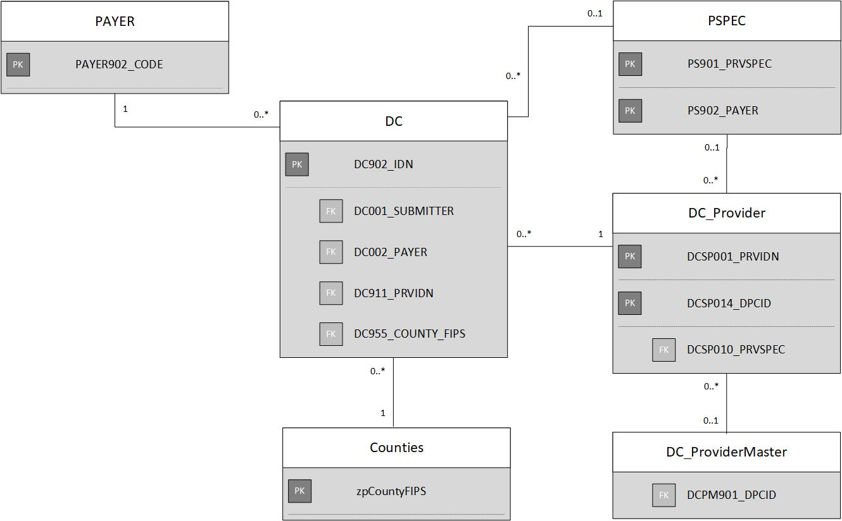

Support Table
Table | Table Description | Primary Key | Related Table Name | Related Table Description | Related Key
PAYER | Payer Code Support Table | PAYER902_CODE | DC | Dental Claims Release Table | DC001_SUBMITTER,  DC002_PAYER
PSPEC | Payer Assigned Specialty Codes Support Table | PS902_PAYER | DC | Dental Claims Release Table | DC001_SUBMITTER
 |  | PS901_PRVSPEC | DC_Provider | Dental Claims Service Provider Support Table | DCSP010_PRVSPEC
DC_Provider | Dental Claims Service Provider Support Table | DCSP001_PRVIDN | DC | Dental Claims Release Table | DC911_PRVIDN
 |  | DCSP014_DPCID | DC_ProviderMaster | Dental Claims Provider Master Support Table | DCPM901_DPCID
Counties | Counties Support Table | zpCountyFIPS | DC | Dental Claims Release Table | DC955_COUNTY_FIPS

Eligibility

Diagram
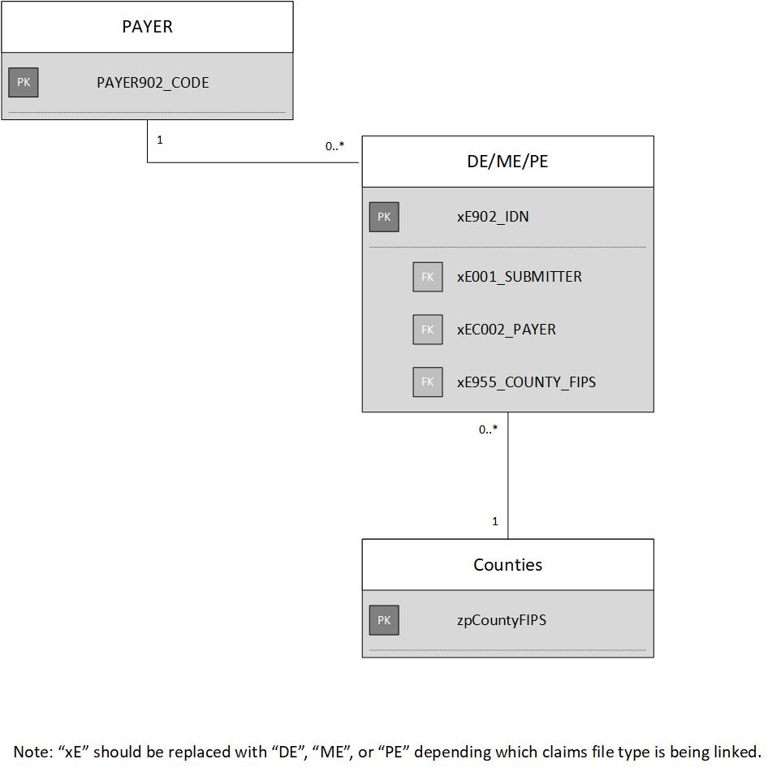

Support Table
Table | Table Description | Primary Key | Related Table Name | Related Table Description | Related Key
PAYER | Payer Code Support Table | PAYER902_CODE | DE/ME/PE | Eligibility Release Table | xE001_SUBMITTER,  xE001_PAYER
Counties | Counties Support Table | zpCountyFIPS | DE/ME/PE | Eligibility Release Table | xE955_COUNTY_FIPS

