CompareMaine
September 2017 MHDO Board Meeting

Data Update Requirements
Title 22, Chapter 1683 section 8712 (2) Payments. The organization shall create a publicly accessible interactive website that presents reports related to payments for services rendered by health care facilities and practitioners to residents of the State. The services presented must include, but not be limited to, imaging, preventative health, radiology and surgical services and other services that are predominantly elective and may be provided to a large number of patients who do not have health insurance or are underinsured. The website must also be constructed to display prices paid by individual commercial health insurance companies, 3rd-party administrators and, unless prohibited by federal law, governmental payors. Beginning October 1, 2012, price information posted on the website must be posted semiannually (every six months or 2x/year), must display the date of posting and, when posted, must be current to within 12 months of the date of submission of the information.

Update Schedule
Site Updated | Version | Cost Data Period | Quality Measures Updated | Status
June 30, 2016 | 2.0 | 10/1/2014-9/30/2015 | HCAHPS Patient Experience Summary Star,  SIR for C. diff and MRSA | Complete
November 30, 2016 | 3.0 | No Cost Data Update | HCAHPS Patient Experience Summary Star, Serious Complications (PSI90), SIR for C. diff and MRSA | Complete
October 20, 2017 | 4.0 | 10/1/2015-12/30/2016 | HCAHPS Patient Experience Summary Star, SIR for C. diff and MRSA | In progress
March 30, 2018 | 5.0 | 7/1/2016-6/30/2017 | HCAHPS Patient Experience Summary Star, PCMH / CG CAHPS Overall Provider Rating, Serious Complications (PSI90), SIR for C. diff and MRSA | Upcoming
June 29, 2018 | 6.0 | No Cost Data Update | HCAHPS Patient Experience Summary Star, SIR for C. diff and MRSA | Upcoming
September 30, 2018 | 7.0 | 1/1/2017-12/31/2017 | HCAHPS Patient Experience Summary Star, Serious Complications (PSI90), SIR for C. diff and MRSA | Upcoming

CompareMaine 4.0; October 20, 2017
- Update HCAHPS Patient Experience Summary Star (7/1/15-6/30/16) and SIRs (7/1/15-6/30/16)
- Update cost data (10/1/15-12/30/16)
- Implement MAD
- Implement new facility review process
- Revise methodology for skin lesion removal procedures
- Regroup rural health facility locations together instead of separately
- Breakout professional and facility costs in current display

CompareMaine 5.0; March 30, 2018
- Update PCMH/CG CAHPS Overall Provider Rating (2016-2017), HCAHPS Patient Experience Summary Star (10/1/15-9/30/16), Serious Complications (7/1/14-6/30/16), and SIRs (10/1/15-9/30/16)
- Update cost data (7/1/16-6/30/17)
- Detailed display for researchers
- Explore adding a feature to filter results in the data display by facility type
- Revised quality data display with new measures at the procedure level
- Cost data trend comparison

Details on CompareMaine 4.0 Enhancements

Implement Median Absolute Deviation (MAD) Process
The Median Absolute Deviation (MAD) Process automatically identifies outliers on CompareMaine and flags them for further investigation. The MAD is used to investigate how widely data points deviate from the median. The process will indicate how much a facility’s cost estimate for a healthcare procedure deviates from the statewide median for that procedure.

The MAD will identify combinations of facilities, payers and procedures that are higher or lower than the established thresholds for deviation from the statewide median for that procedure. Given that health care costs have natural variation, this procedure will be used to identify extreme outliers that are artifacts of the APCD data. Once outliers have been identified, we will drill down internally to determine the potential cause for the result. The facility and/or payer will also be contacted if its median is above or below the statewide median by five deviations and +/- $100.

Table 1: CompareMaine 4.0 Outliers by Payer
Payer | # Outlier Estimates
Aetna | 53
Anthem | 28
CIGNA | 42
Harvard Pilgrim | 14
Maine Community Health Options | 10
All Payers | 41
Total | 188

Revised Methodology for Skin Lesion Removal
In previous versions of CompareMaine, skin lesion estimates for CPT codes 17000 and 17110 were calculated using the 3M’s Medical Episode Grouper, a tool that creates episodes of care by analyzing claims data to identify diagnoses. The MEG created some high cost episodes for these codes that involved some intensive services such as cancer treatments. We felt these episodes were not representative of the code and removed both procedures from the site. After analysis, we revised to methodology to calculate these procedures as follows:
There are two skin lesion procedures on CompareMaine. One for the removal of precancerous skin (17000) and one for the removal of noncancerous skin (17110). The removal of precancerous skin is bundled with the cost of the office visit in which the removal occurs (CPT Codes 99385-99386, 99395-99396, 99201-99205, 99211-99215, 99381-99384, 99391-99394, 99241-99245), the biopsy (CPT 88305), and the pathology exam (CPT 11100). The removal of noncancerous skin is bundled with the cost of the office visit in which the removal occurs (CPT 99385-99386, 99395-99396, 99201-99205, 99211-99215, 99381-99384, 99391-99394, 99241-99245).

Regroup Rural Facilities
During the QC of CompareMaine 2.0, the following organizations requested that we regroup their facilities. Previously, each location of the network was displayed separately. In CompareMaine 4.0, the locations will be grouped together into their respective networks. This has following potential impacts: an increase in the number of facilities reporting data in the network, and increase in the number of procedures displayed on CompareMaine for that network, and an increase in the number of claims per procedure. Italics indicate facilities not previously included on CompareMaine due to low N issues.
- Community Clinical Services
  - B Street Health Center
  - CCS Family Health Center
  - CCS Psychiatry at Central Maine Family Practice
  - Second Street Health Center
- Penobscot Community Health Care
  - Brewer Medical Center
  - Capehart Community Clinic
  - Helen Hunt Health Center
  - Jackman Community Health Center
  - Pediatrics
  - Penobscot Community Health Center
  - Seaport Community Health Center
  - Specialty Clinic
  - Summer St. Community Clinic
  - Winterport Community Health Center
- Pines Health Services
  - Kimball Community Health Center
  - Pines Caribou Health Center
  - Presque Isle Health Center
  - St. John Valley Health Center
  - Washburn Health Center
  - Women and Children’s Center
- Portland Community Health Center
  - Portland Community Health Center (PCHC)
  - PCHC at Brickhill
  - PCHC at Franklin Towers
  - PCHC at Preble St.
  - PCHC at Riverton Park
- HOMETOWN Health Center (Formerly Sebasticook Family Doctors)
  - Canaan
  - Dexter
  - Dover-Foxcroft
  - Newport
  - Pittsfield

Breakout of Professional and Facility Costs
The average total cost is broken out by professional and facility costs:

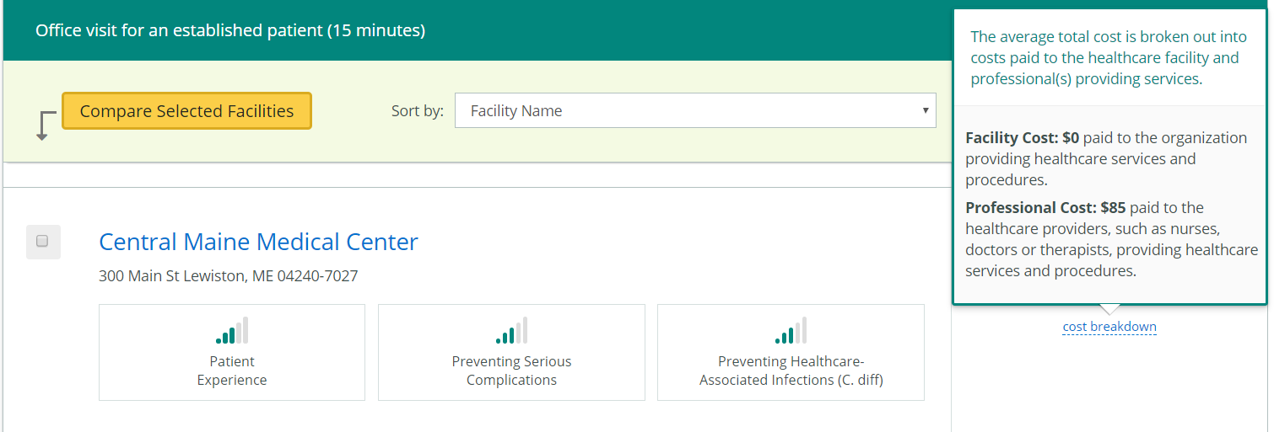

HCAHPS Patient Experience Summary Star will be updated annually in June - the data currently on CompareMaine are from 7/1/2014-6/30/2015, data are downloaded from CMS Hospital Compare, https://www.medicare.gov/hospitalcompare/Data/Data-Updated.html#. PCMH/CG CAHPS Overall Provider Rating will be updated every two years in November - the data currently on CompareMaine are from 2014 and 2015, data are downloaded from Patient Experience Matters http://www.mainepatientexperiencematters.org/about-the-data.php; CAHPS Database (Westat). Serious Complications will be updated annually in November - the data currently on CompareMaine are from 7/1/2013-6/30/2015, data are downloaded from CMS Hospital Compare, https://www.medicare.gov/hospitalcompare/Data/Data-Updated.html#. SIRs for C. diff and MRSA will be updated every June and November - the data currently on CompareMaine are from 10/1/2014-9/30/2015, data are downloaded from CMS Hospital Compare, https://www.medicare.gov/hospitalcompare/Data/Data-Updated.html#
The CompareMaine 3.0 data update originally scheduled for November 30, 2016 did not take place due to the impact of the Gobeille vs. Liberty Mutual.
CompareMaine interface enhancements will be made.

