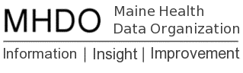

AGENDA

BOARD OF DIRECTORS MEETING

Finance Authority of Maine

Board Room
5 Community Drive
Augusta, Maine

Thursday, June 7, 2018

2:00 pm - 3:00 pm

Call in Number: (877) 455-0244; Conference Code: 7281882859

Chair Report
Vote to approve December 7, 2017 Minutes

Acting Executive Director Report
Review Comments and Proposed Responses to Rule Chapter 243: Uniform Reporting System for Health Care Claims Data Sets
Vote to adopt Rule Chapter 243: Uniform Reporting System for
Health Care Claims Data Sets
Vote to initiate rulemaking for Chapter 270: Uniform Reporting
System for Health Care Quality Data Sets
Request to Develop & Release an RFP for Consulting Services to Support LD 1406

Public Comment

Adjourn

Next MHDO Board Meeting: September 6, 2018. 9am-11am

