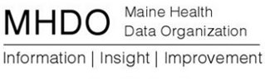

AGENDA

BOARD OF DIRECTOR MEETING

151 Capitol Street, Augusta, Maine

Thursday, November 5, 2015

9:00 a.m. - 11:00 a.m.

Chair Report
Vote to approve October 1, 2015 Minutes
Legislative Update
Status of Board Appointments
Board Chair Transition Planning

Acting Executive Director Report
CompareMaine Update & Next Steps
Review Project Deliverables and Timeline for Next 12 months
Status of Data Releases
11/17 meeting Re: Value Based Purchasing & eCQM’s
December 3rd MHDO Board Meeting
Maine Quality Forum
Public Comment
Adjourn

