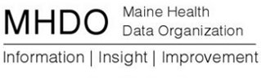

AGENDA

BOARD OF DIRECTOR MEETING

151 Capitol Street, Augusta, Maine

Thursday, January 7, 2016

9:00 a.m. - 11:00 a.m.
Call in Number: (877) 455-0244; Conference Code: 7281882859

Chair Report
Vote to approve December 3, 2015 Minutes
Vote to appoint Chair-elect
Legislative Update
Acting Executive Director Report
Review of Comments and Proposed Responses to Rule Chapter 120: Release of Data to the Public and Rule Chapter 270: Uniform Reporting Systems for Quality Data Sets
Vote to provisionally adopt Rule Chapter 120: Release Of Data to the Public
Vote to provisionally adopt Chapter 270: Uniform Reporting System for Quality Data Sets

Maine Quality Forum (MQF)
Update

Public Comment
Adjourn

