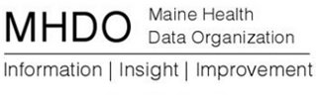

AGENDA

BOARD OF DIRECTOR MEETING

151 Capitol Street
Augusta, Maine

Thursday, January 28, 2016

9:00 a.m. - 10:30 a.m.

Call in Number: (877) 455-0244; Conference Code: 7281882859

Agency Business
Continued Review of Comments and Responses to Rule Chapter 120: Release of Data to the Public
Vote to provisionally adopt Rule Chapter 120: Release Of Data to the Public
Public Comment
Adjourn

