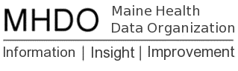

AGENDA

BOARD OF DIRECTORS MEETING

151 Capitol Street, Augusta, Maine

Thursday, September 6, 2018

9:00 a.m. - 11:00 a.m.
Call in Number: (877) 455-0244; Conference Code: 7281882859

Public Hearing -9am
Rule Chapter 270: Uniform Reporting on Health Care Quality Data Sets
Chair Report-10am
Vote to approve June 7, 2018 Minutes
Review of June 7, 2018 Board Retreat Notes
Status of Board Appointments
Data Use Case-Southern Maine Agency on Aging
Executive Director Report
MHDO & HSRI Contract Amendment
Review Highlights of CompareMaine 6.0 Release
Status of MHDO Data Releases
Status of LD 1406 Section 1
Update on SAMHSA 42 CFR Part 2
Maine Quality Forum (MQF)
Public Comment
Adjourn

