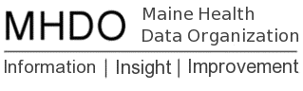

AGENDA

BOARD OF DIRECTORS MEETING

FAME Board Room
5 Community Drive, Augusta, Maine

Thursday, June 1, 2017

2:00 p.m. - 3:00 p.m.
Call in Number: (877) 455-0244; Conference Code: 7281882859

Chair Report
Vote to approve March 2, 2017 Minutes
Board Appointments
Acting Executive Director Report
Vote to Initiate Rulemaking for Chapter 241: Uniform Reporting System for Hospital Inpatient and Outpatient Data Sets
Vote to Initiate Rulemaking for Chapter 243: Uniform Reporting System for Health Care Claims Data Sets
Maine Quality Forum (MQF)
Recent Posting of RFP to Support the Development of the Maine Quality Forum Annual Healthcare Associated Infections Report
Public Comment
Adjourn

