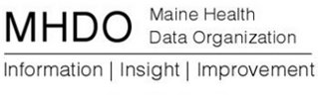

AGENDA

MHDO VALUE PROPOSITION SUBCOMMITTEE MEETING

151 Capitol Street, Augusta, Maine

Tuesday, August 9, 2016

1:00 p.m. - 2:00 p.m.
Call in Number: (877) 455-0244; Conference Code: 7281882859

- Welcome
- Review Charge of Subcommittee
- Update on Gobeille and CompareMaine 2.0

- Value Proposition in the State of Virginia (discussion starts at 1:30 with Michael Lundberg-Executive Director and Kyle Russell-APCD Program Manager for Virginia Health Information)

- Next Steps

- Public Comment

- Adjourn

