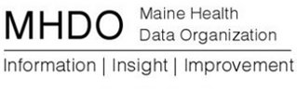
Ad Hoc Consumer Group
Agenda
Friday, September 8, 1:00pm to 3:00pm
Board Room, MHDO, 151 Capitol Street, Augusta

Remote Participation Instructions

We encourage in-person attendance but if necessary, here’s how to participate remotely:
- Join the call: https://www.uberconference.com/mhillmyer
- Optional dial in number: 617-545-3859 (no pin needed)

Agenda

1:00 Opening
Welcome and Introductions – Craig Freshley, facilitator

1:05 Community Consumer Education & Outreach for Antibiotic Resistance and Healthcare Associated Infections
Maine CDC & Healthcentric Advisors

2:00 Updates Since the Last Meeting
Status and Preview of CompareMaine 4.0–Karynlee & Melissa
Updates on status of new potential quality measures
Review updates to site planned for release 5.0

Updates from members-All

2:50 Next Meeting and Plus-Delta

3:00 Adjourn

