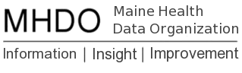

Data Delivery Model Workplan
Internal Working Document-July 2018
Contents
Introduction 2
MHDO Data Warehouse Capabilities 2
Analysis Ready Datasets 2
Basic Groupers 3
Analytic Groupers 3
Enhanced Data Releases 4
Methodology Bank 4
Access to Data and Information 4
Public Reports 4
Timeline 5

Introduction
This document outlines the framework being used to further define the MHDO Data Delivery Model, as well as a working timeline for implementation.

MHDO Data Warehouse Capabilities
The diagram below depicts the full vision for the MHDO Data Warehouse and the status of each item as of July 2018. Most of the items in this diagram cover both All-Payer Claims Data (APCD) and Hospital Encounter Data, however there are some data source-specific items such as claim versioning for APCD.
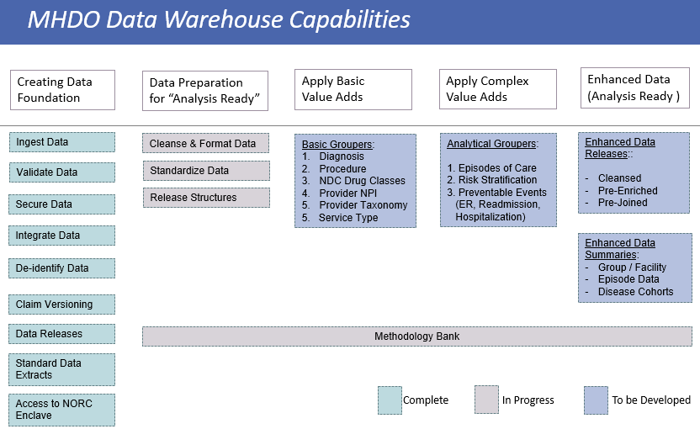

Analysis Ready Datasets
The envisioned “analysis ready” datasets are data structures similar to the current releasable data structures, only that they would be further scrutinized and enhanced in order to streamline subsequent standard reporting. The following information provides an overview of the main objectives to be reached as part of the data preparation process.

Data Cleansing: amending or editing codes in the database that are incorrect, incomplete, improperly formatted, or duplicated. Examples:
- “Codes” Data Fields
  - Diagnose Codes DX1-DX4X (ICD9-10)
  - Procedure (CPT/HCPCS/ICD-CM) and Modifiers
  - Drug Codes (NDC)
  - Revenue Codes
  - Health Care Provider Taxonomy Codes (CMS/NUCC)
  - Industry Classification codes (SIC)
- “Dates” Data Fields
  - Service Dates (Claim & Claim Line level)
  - Admission and Discharge Dates
  - Prescription and Fill/Refill Dates

Data Standardization: harmonize data from different sources into standard formatting for Provider, Facility and Member geo data fields.
- Standardize Addresses USPS format
- Cities Standardization (Multiple Spellings)
- State Standardization (Multiple Spellings)
- Zip Codes Formatting and Correction

Release Structures: create new release views that make the summary / header information more accessible, and are separated from the detailed, service level data. Example: Claim Header views separated from Claim Line views.

Basic Groupers
- Diagnosis Grouper into Conditions and Diseases
  - Clinical Classification Software (CCS AHRQ)
  - Major Disease Categories (MDC)
- Procedure Grouper into Procedure Categories and Subcategories:
  - BETOS from CMS
  - Clinical Classification Software (CCS AHRQ)
- NDC Grouper into Drug Classes:
  - FDA/NDC
  - Therapeutical Class Grouper (AHFS)
- Provider Code Grouper into Type, Specialties, Taxonomies
  - NPI database
  - CMS/NUCC taxonomy classification
- Payer Type / Line of Business (Commercial, Medicaid, Medicare Fee-For-Service, Medicare Advantage, Other; at the month level or annualized, based on eligibility and claim records)
- Service Type Grouper (IP/OP/PROF categories)
- Ancillary Enrichment (Zip-County-HSR-CBSB, Industry Codes SIC, etc.)
- Inpatient Reimbursement (MS DRG / APR DRG – MDC)
Note: The software above are mostly open source or very cost-effective options, industry standard lookups used by most researchers and private organizations to enrich the claims data; implementing this in MHDO data warehouse is an efficient and effective option, assuming the data cleaning phase is completed.

Analytic Groupers
- Episode of Care
  - ECR, ETG, MEG
- Patient Risk Scores
  - JHU HCC, ACG, DXCG
- Population Risk Stratification
  - 3M™ CRG, JHU ACG
- Preventable and Population Health Grouping
  - 3M™ PPE, potential preventable events combining:
    - 3M™ PPR (Preventable readmissions),
    - 3M™ PPC (Preventable complications),
    - 3M™ PPS (Potentially preventable hospitalizations, Potentially preventable ED visits, Hospital-acquired conditions HACs)
Note: Most of the software packages for the analytic data groupers are proprietary and may incur significant cost and licensing considerations; implementation should be prioritized based on stakeholder and sustainability objectives.

Enhanced Data Releases
- Examples:
  - Data Sets that are Cleansed and Pre-Joined
  - Summary Data Sets

Methodology Bank
MHDO will build and maintain a repository of information on measure construction and analytical methods used for past and current MHDO reporting.

Access to Data and Information
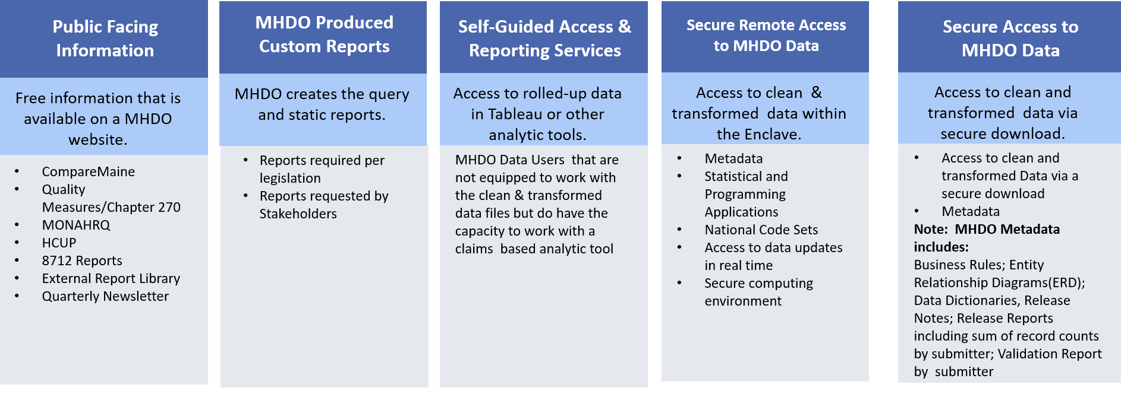

Public Reports
MHDO will create a set of public reports to answer common questions and demonstrate the potential uses of the MHDO APCD and hospital data.

Timeline
Task Name | Duration | Start | Finish
Data Delivery Model | 267 days | Thu 6/21/18 | Fri 6/28/19
Analysis Ready Datasets | 243 days | Wed 7/25/18 | Fri 6/28/19
Discuss proposal for data cleansing and standardization with SDUG | 1 day | Wed 7/25/18 | Wed 7/25/18
Finalize proposal for data cleansing and standardization | 17 days | Thu 7/26/18 | Fri 8/17/18
Implement proposal with release of Q2 2018 hospital inpatient data | 5 days | Mon 11/26/18 | Fri 11/30/18
Implement proposal with release of Q3 2018 APCD data | 5 days | Mon 1/14/19 | Fri 1/18/19
Implement proposal with release of hospital outpatient data | 5 days | Mon 6/24/19 | Fri 6/28/19
Basic Groupers | 243 days | Wed 7/25/18 | Fri 6/28/19
Discuss proposal for basic groupers with SDUG | 1 day | Wed 7/25/18 | Wed 7/25/18
Finalize proposal for basic groupers | 17 days | Thu 7/26/18 | Fri 8/17/18
Acquire, setup and test basic groupers | 30 days | Mon 8/20/18 | Fri 9/28/18
Implement proposal with release of Q2 2018 hospital inpatient data | 5 days | Mon 11/26/18 | Fri 11/30/18
Implement proposal with release of Q3 2018 APCD data | 5 days | Mon 1/14/19 | Fri 1/18/19
Implement proposal with release of hospital outpatient data | 5 days | Mon 6/24/19 | Fri 6/28/19
Analytic Groupers | 131 days | Mon 7/2/18 | Mon 12/31/18
Draft working outline of RFP | 5 days | Mon 7/2/18 | Fri 7/6/18
Develop and finalize survey content | 45 days | Mon 7/2/18 | Fri 8/31/18
Develop survey in Survey Monkey | 4 days | Tue 9/4/18 | Fri 9/7/18
Deploy survey to stakeholders and collect responses (CompareMaine facilities, payers and other interested parties) | 15 days | Mon 9/10/18 | Fri 9/28/18
Develop and finalize RFP content | 23 days | Mon 10/1/18 | Wed 10/31/18
Send RFP to Purchasing | 1 day | Thu 11/1/18 | Thu 11/1/18
Release RFP | 1 day | Mon 12/31/18 | Mon 12/31/18
Enhanced Data Releases | 1 day | Mon 6/25/18 | Mon 6/25/18
TBD
Enhance Data Summaries | 1 day | Mon 6/25/18 | Mon 6/25/18
TBD
Public Facing Information/Reports | 127 days | Thu 6/21/18 | Fri 12/14/18
Conduct environmental scan of other states; send draft to Karynlee | 12 days | Thu 6/21/18 | Fri 7/6/18
Conduct stakeholder survey on measures and reports of interest | TBD
Develop recommendations for measures/metrics to report; send draft to Karynlee | TBD
Discuss recommendations for measures/metrics to report with SDUG | TBD
Finalize priorities for measures/metrics to report | TBD
Develop analysis ready datasets, acquire and integrate basic groupers |  | See above | See above
Develop prototypes for public reports | TBD
Discuss draft reports with Karynlee | TBD
Finalize and publish first iteration of public reports | TBD
Collect external feedback on the first iteration of public reports | TBD
Develop second iteration of public reports | TBD
Discuss draft reports with Karynlee | TBD
Finalize and publish second iteration of public reports | TBD

