Data Delivery Model Workplan
Draft 9/10/2018
Contents
Introduction 2
MHDO Data Warehouse Capabilities 2
Analysis Ready Datasets 2
Basic Groupers 3
Analytic Groupers 4
Enhanced Data Releases 4
Methodology Bank 4
Access to Data and Information 5
Public Reports 5
Timeline 5

Introduction
This document outlines the framework being used to further define the MHDO Data Delivery Model, as well as a working timeline for implementation.

MHDO Data Warehouse Capabilities
The diagram below depicts the full vision for the MHDO Data Warehouse and the status of each item as of July 2018. Most of the items in this diagram cover both All-Payer Claims Data (APCD) and Hospital Encounter Data, however there are some data source-specific items such as claim versioning for APCD.
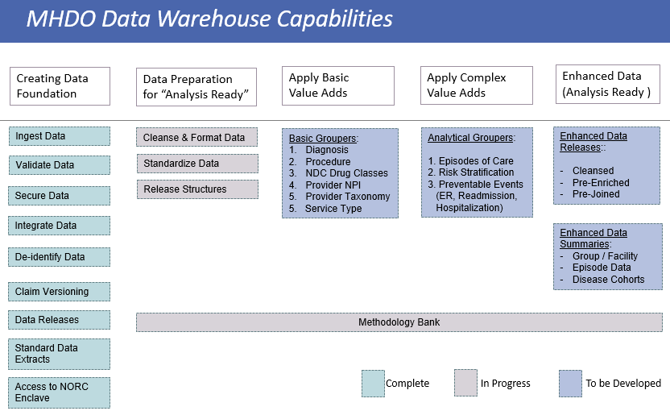

Analysis Ready Datasets
The envisioned “analysis ready” datasets are data structures similar to the current releasable data structures, only that they would be further scrutinized and enhanced in order to streamline subsequent standard reporting. The following information provides an overview of the main objectives to be reached as part of the data preparation process.

What is the Analytic Data set?
The analytic data set is a set of data structures that are populated with data from MHDO’s APCD and Hospital Data Systems. The structure is a simplified format to allow data users to more easily analyze the data without additional restructuring. The data used to populate the data structures would be cleaned using a standard set of business rules that would remove or flag data out of range values.
What data would be available?
We propose that we would start with the ICD10 conversion date of 10/2015 going forward. For the initial release, each data set (APCD and Hospital Inpatient) would have 3 full years of data: 10/2015-9/2018
What variables would be included and cleaned?
We would prioritize variables for inclusion and cleaning based on these criteria:
- Variables listed in Chapter 120 Release Levels 1 and 2
- Variables used to input into other analytic tools, such as groupers
- Variables that data users have indicated as high priority
- Variables that we can validate against external data sets

Data Cleansing: amending or editing codes in the database that are incorrect, incomplete, improperly formatted, or duplicated. Examples:
- “Codes” Data Fields
  - Diagnose Codes DX1-DX4X (ICD9-10)
  - Procedure (CPT/HCPCS/ICD-CM) and Modifiers
  - Drug Codes (NDC)
  - Revenue Codes
  - Health Care Provider Taxonomy Codes (CMS/NUCC)
  - Industry Classification codes (SIC)
- “Dates” Data Fields
  - Service Dates (Claim & Claim Line level)
  - Admission and Discharge Dates
  - Prescription and Fill/Refill Dates

Data Standardization: harmonize data from different sources into standard formatting for Provider, Facility and Member geo data fields.
- Standardize Addresses USPS format
- Cities Standardization (Multiple Spellings)
- State Standardization (Multiple Spellings)
- Zip Codes Formatting and Correction

Release Structures: create new release views that make the summary / header information more accessible, and are separated from the detailed, service level data. Example: Claim Header views separated from Claim Line views.

Basic Groupers
- Diagnosis Grouper into Conditions and Diseases
  - Clinical Classification Software (CCS AHRQ)
  - Major Disease Categories (MDC)
- Procedure Grouper into Procedure Categories and Subcategories:
  - BETOS from CMS
  - Clinical Classification Software (CCS AHRQ)
- NDC Grouper into Drug Classes:
  - FDA/NDC
  - Therapeutical Class Grouper (AHFS)
- Provider Code Grouper into Type, Specialties, Taxonomies
  - NPI database
  - CMS/NUCC taxonomy classification
- Payer Type / Line of Business (Commercial, Medicaid, Medicare Fee-For-Service, Medicare Advantage, Other; at the month level or annualized, based on eligibility and claim records)
- Service Type Grouper (IP/OP/PROF categories)
- Ancillary Enrichment (Zip-County-HSR-CBSB, Industry Codes SIC, etc.)
- Inpatient Reimbursement (MS DRG / APR DRG – MDC)
Note: The software above are mostly open source or very cost-effective options, industry standard lookups used by most researchers and private organizations to enrich the claims data; implementing this in MHDO data warehouse is an efficient and effective option, assuming the data cleaning phase is completed.

Analytic Groupers
- Episode of Care
  - ECR, ETG, MEG
- Patient Risk Scores
  - JHU HCC, ACG, DXCG
- Population Risk Stratification
  - 3M™ CRG, JHU ACG
- Preventable and Population Health Grouping
  - 3M™ PPE, potential preventable events combining:
    - 3M™ PPR (Preventable readmissions),
    - 3M™ PPC (Preventable complications),
    - 3M™ PPS (Potentially preventable hospitalizations, Potentially preventable ED visits, Hospital-acquired conditions HACs)
Note: Most of the software packages for the analytic data groupers are proprietary and may incur significant cost and licensing considerations; implementation should be prioritized based on stakeholder and sustainability objectives.

Enhanced Data Releases
- Examples:
  - Data Sets that are Cleansed and Pre-Joined
  - Summary Data Sets

Methodology Bank
MHDO will build and maintain a repository of information on measure construction and analytical methods used for past and current MHDO reporting.

Access to Data and Information
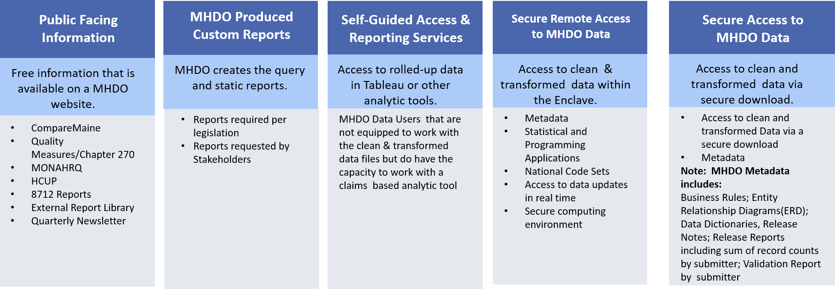

Public Reports
MHDO will create a set of public reports to answer common questions and demonstrate the potential uses of the MHDO APCD and hospital data.

Timeline
Task Name | Duration | Start | Finish
Data Delivery Model | 337 days | Thu 6/21/18 | Fri 10/4/19
Analysis Ready Datasets | 243 days | Wed 7/25/18 | Fri 6/28/19
Discuss proposal for data cleansing and standardization with SDUG | 1 day | Wed 7/25/18 | Wed 7/25/18
Finalize plan for data cleansing and standardization | 21 days | Fri 8/31/18 | Fri 9/28/18
Analysis Ready Dataset Available for APCD Users | 130 days | Mon 10/1/18 | Fri 3/29/19
Analysis Ready Dataset Available for Hospital Inpatient Users | 65 days | Mon 4/1/19 | Fri 6/28/19
Basic Groupers | 313 days | Wed 7/25/18 | Fri 10/4/19
Discuss proposal for basic groupers with SDUG | 1 day | Wed 7/25/18 | Wed 7/25/18
Finalize proposal for basic groupers | 47 days | Thu 7/26/18 | Fri 9/28/18
Acquire, setup and test basic groupers | 160 days | Mon 8/20/18 | Fri 3/29/19
Produce basic grouper output for APCD | 90 days | Mon 4/1/19 | Fri 8/2/19
Produce basic grouper output for Hospital | 70 days | Mon 7/1/19 | Fri 10/4/19
Analytic Groupers | 131 days | Mon 7/2/18 | Mon 12/31/18
Draft working outline of RFP | 5 days | Mon 7/2/18 | Fri 7/6/18
Develop and finalize RFP content- modified to recommend analytic grouper | 23 days | Mon 10/1/18 | Wed 10/31/18
Present grouper recommendation | 1 day | Thu 11/1/18 | Thu 11/1/18
Finalize and approve recommendation | 8 days | Thu 11/1/18 | Fri 11/9/18
Secure grouper and implement in Data Enclave | 24 days | Fri 11/9/18 | Fri 11/30/18
Enhanced Data Releases | 1 day | Mon 6/25/18 | Mon 6/25/18
TBD
Enhance Data Summaries | 1 day | Mon 6/25/18 | Mon 6/25/18
TBD
Public Facing Information/Reports | 12 days | Thu 6/21/18 | Fri 7/6/18
Conduct environmental scan of other states; send draft to Karynlee | 12 days | Thu 6/21/18 | Fri 7/6/18
Conduct stakeholder survey on measures and reports of interest |  | TBD | TBD
Develop recommendations for measures/metrics to report; send draft to Karynlee |  | TBD | TBD
Discuss recommendations for measures/metrics to report with SDUG |  | TBD | TBD
Finalize priorities for measures/metrics to report |  | TBD | TBD
Develop analysis ready datasets, acquire and integrate basic groupers |  | TBD | TBD
Develop prototypes for public reports |  | TBD | TBD
Discuss draft reports with Karynlee |  | TBD | TBD
Finalize and publish first iteration of public reports |  | TBD | TBD
Collect external feedback on the first iteration of public reports |  | TBD | TBD
Develop second iteration of public reports |  | TBD | TBD
Discuss draft reports with Karynlee |  | TBD | TBD
Finalize and publish second iteration of public reports |  | TBD | TBD

