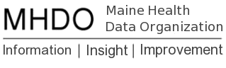

Annual Update Instructions
Last Updated: April 1, 2019

Purpose
The purpose of the upcoming changes and activities in the portal is to:
- Review and update (if necessary) all portal registration information including hospital information, contacts, and users (permissions).
- Evaluate 2019 data against all validation rules by resetting all existing Profile– and Exemption–Level validation rule overrides.
- Revise validation rules to improve data quality.
These updates will ensure the accuracy and quality of registration and validation information within the MHDO Hospital Data Portal.

Timelines
Task | Start Date | End Date
Files submitted in this period will be held and processed on 4/3/2019 | 4/1/2019 | 4/2/2019
Validation changes implemented, and annual override reset occurs | 4/2/2019 | 4/2/2019
Annual registration information updates due | 4/3/2019 | 4/30/2019
Q1 2019 data files are due | 6/30/2019 | 6/30/2019

Annual Registration Update Instructions
Action Required from: Administrator Users
- Login. Login to the MHDO Hospital Data Portal between April 3rd and April 30th, 2019.
- Review and Update Users
  - One Administrator User from each facility must review and update their facility’s users in order to complete the 2019 annual registration. Please add, remove or change permissions for users as appropriate. An explanation of permissions can be found in the User Manual (pages 5-7).
  - Click Confirm Registration Update 2018 - Users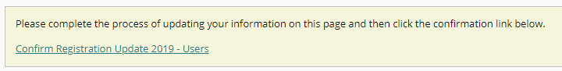
  - Click the Confirm button
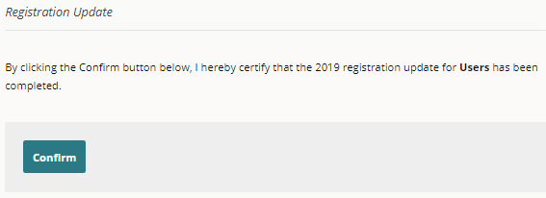
- Review and Update Contacts
  - Each facility must have at least one Administrator and Data Submitter. Accurate information ensures the proper people receive emails from the MHDO Hospital Data Portal and from the MHDO.
  - An explanation of roles can be found in the User Manual (pages 7-9).
  - Click Confirm Registration Update 2018 - Users 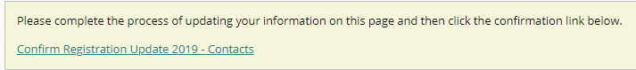
  - Click the Confirm button
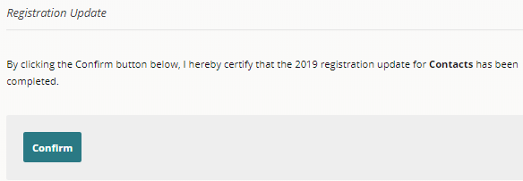
- Review and Update Summary.
  - Please review your facility’s Campus, Campus Sub entities (clinics), and Data Streams. One Administrator User from each company must review and contact the Help Desk (mhdohelp@hsri.org) regarding changes to this information. MHDO Staff will make all edits to information on this page.
  - Click Confirm Registration Update 2018 - Users
  - Click the Confirm button
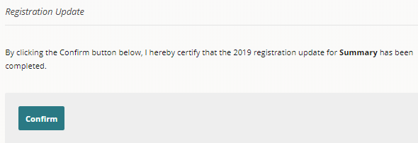

- Completion of 2019 Updates. Once steps 1-4 have been completed successfully a message indicating the 2019 updates are completed will be displayed at the top of the Uses, Contacts, and Summary screens. Please complete these steps by April 30th, 2019. Failure to complete your updates may result in delays processing files and the release of MHDO’s data to authorized data users.
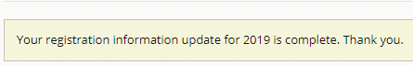

Validation Override Review Instructions
Action Required from: Data Submitters
- Review 2018 Validation Report. Information about how your data performed against the validation rules in the past can be found in the Validation Report. Further instructions for using the report with screen shots can be found in the User Manual (pages 18-19).
- Submit Quarter 1 2019 Data. Submit your Quarter 1 2019 data to the MHDO Hospital Data Portal between April 3rd and June 30th, 2019. Note: If you are unable to submit your data by June 30th, these instructions still apply.
- Review and Resolve Validation Issues. Due to all Profile and Exemption-Level overrides being reset, most users will have validation issues to review and resolve. Once you click “Request Override” for a given Profile or Exemption-Level issue you will see a history of past overrides (if there are any), including the reason for the override or termination of the override, for that rule. Further instruction and screenshots can be found in the User Manual (page 16-18).

Validation Rule Updates
To continuously improve data quality, we are making a handful of changes and additions to validation rules. For a summary of these changes, see the hospital validation changes spreadsheet located on our Hospital Data Submitter Group page.

Help and Reporting Issues
All questions and issues encountered in the portal should be directed to the MHDO Help Desk.
Toll-free Phone: (866) 451-5876
Email: mhdohelp@hsri.org

