MHDO Analytic Dataset Proposal
Last Updated 11/21/2018

Overview
The new MHDO Data Delivery Model calls for the creation of “analysis ready” datasets that will allow data users to more easily analyze the data without additional restructuring or cleaning. This document outlines these new analysis-ready release structures and the steps that will be taken to create them.

Current Structure
Currently, data from the MHDO APCD are released to data users as monolithic data tables accompanied by a series of support tables. The six main tables are for:
- Dental claim lines,
- Medical claim lines,
- Pharmacy claim lines,
- Dental eligibility,
- Medical eligibility, and
- Pharmacy eligibility.
The support tables are:
- Medical claims consolidation (identifies medical claim lines to use to obtain latest version of a given claim),
- Counties,
- Home-grown CPT codes,
- Home-grown diagnosis codes,
- Provider detail and master tables (one set each for dental, medical, and pharmacy claims),
- Payer codes,
- Provider specialty codes.
These formats can be difficult for some data users to make use of. For instance, in order to perform claim-level analyses, data users have to roll up individual claim lines into a claim-level record. Information about a claim’s ICD procedure codes is spread out across 25 different ICD-10 procedure code fields and one ICD-9 field. Information about a claim’s diagnosis codes is spread out across 53 ICD-10 fields and 15 ICD-9 fields. This structure can make even very basic queries quite complex.
Member eligibility records provide member demographic information such as gender, date of birth, and patient location on each monthly record. If there are variations in this information across time, this can lead to analytic problems when reporting by age or patient location.

Proposed Structure
The proposed analytic structures will provide simpler, summarized data structures that data users will be able to take advantage of. Information that is unique to a claim or member will be cleaned and presented on claim-level or member-level tables with any inconsistencies resolved and flagged. When there are several different fields conveying similar information, such as diagnosis code information, this information will be transposed into a narrow table that can be more easily queried.
Provider information will be simplified so that each claim is unambiguously associated with a single record on a provider composite table that covers all provider types (a claim can have servicing/rendering, billing, attending, operating, and referring providers listed). The same provider table will be used for dental, medical, and pharmacy claims.
Critical data quality issues on records will be communicated to end users using flag variables; this will allow data users to easily include and exclude records based on the scope of their analysis. The use of flag variables will eliminate the need to distribute a separate claim consolidation table and provide the most flexibility to end users.
Flags will also be used to identify field values that are non-standard “home-grown” codes, allowing data users to drop these values from their analysis. The “home-grown” code tables will continue to be distributed but will not be tightly integrated into the analytic dataset structure. That is, the cleaning process will identify if a given non-standard code appears on the appropriate “home-grown” table, but the corresponding description information will not appear in the analytic structure. In general, these codes are not useful for standard reporting and value-add processing since they are only specific to a given payer and then only for a period of time, typically.

Medical Claims Data Structures
The medical claims will be restructured into the following tables (see Appendix A for details):
- Medical Claims Header—one row per claim providing all claim-level information
- Medical Claim Line—one row per claim line with all claim line-level information
- Medical Claim DX—one row for each diagnosis code on claim.
- Medical Claim PX—one row for each ICD procedure code on claim (Please note: HCPCS/CPT procedure codes would be present in the Medical Claim Line table only.)
Note that claim DX and ICD-based PX codes are expected to represent claim-level information. However, the data cleaning process will test for situations where the codes differ across lines of the same claim and ensure that codes appearing on any claim line are captured; the claim would then be flagged as having a data quality issue.

Dental Claims Data Structures
The Dental claims will be restructured into the following tables:
- Dental Claims Header—one row per claim providing all claim-level information
- Dental Claim Line—one row per claim line with all claim line-level information

Pharmacy Claims Data Structures
The Pharmacy claims will be restructured into the following tables:
- Pharmacy Claims Header—one row per claim providing all claim-level information
- Pharmacy Claim Line—one row per claim line with all claim line-level information
- Pharmacy—one row for each pharmacy appearing in a claim

Member Eligibility Data Structures
In the current data structures, dental, medical, and pharmacy eligibility data is stored on separate tables. However, this information comes to us all on a single table. Each record has a set of flags indicating what type(s) of eligibility it is for. Thus, a single source record could end up being stored in three different places. For the analysis-ready datasets, these records will be reunified. Thus, we will only have one set of eligibility data structures. However, data requesters will still only obtain access to the type of eligibility data they request (dental, medical, pharmacy, or a combination of these types).
Please note that the claim headers include member demographic information. If we were guaranteed that every claim would be able to be associated with an eligibility record, we could omit these fields. However, since we know we don’t have 100% linkage between claims and eligibility in the MHDO APCD, we propose that we continue to supply this information on the claim records. When this information conflicts with the demographics provided in the eligibility data, the claim record will be flagged.
The MHDO-Assigned Member ID is constructed from the date of birth and gender information provided by the payer, along with either a member SSN, a subscriber SSN, or a contract number. When it is constructed from a contract number, it only identifies a member within a particular payer contract relationship. When it is constructed from an SSN, it generally can be used to identify a person between payers that also provide an SSN. The MHDO-Assigned Member ID will be revised to include additional identifiers (HICN and MBI) once we start receiving these fields in early 2019.
The member eligibility will be restructured into the following tables:
- Member—one row per MHDO-assigned member ID providing demographic information such as gender and date of birth. Note that information on member’s location of residence will not appear on this table, since this may change over time.
- Member Eligibility—one row per valid member eligibility record (after unification of dental, medical, and pharmacy into one record). This will generally be one row per member per month per payer. However, there may be cases where a member has two or more types of eligibility from a given payer in a given month (i.e., multiple insurance product types). Member location of residence will appear on this table since it is tied to a particular point in time, payer and insurance type.

Provider Data Structures
- Provider—one row for each provider appearing in a claim, regardless of provider type (i.e., provider A will only have one row, even if it appears as both a rendering and a billing provider)

Appendix A Proposed Medical Claims Release Structures
Note: Actual release structure column names are yet to be determined but will be unique to the release structures. Data quality flags are not shown, since they haven’t been finalized yet.

Medical Claims Header
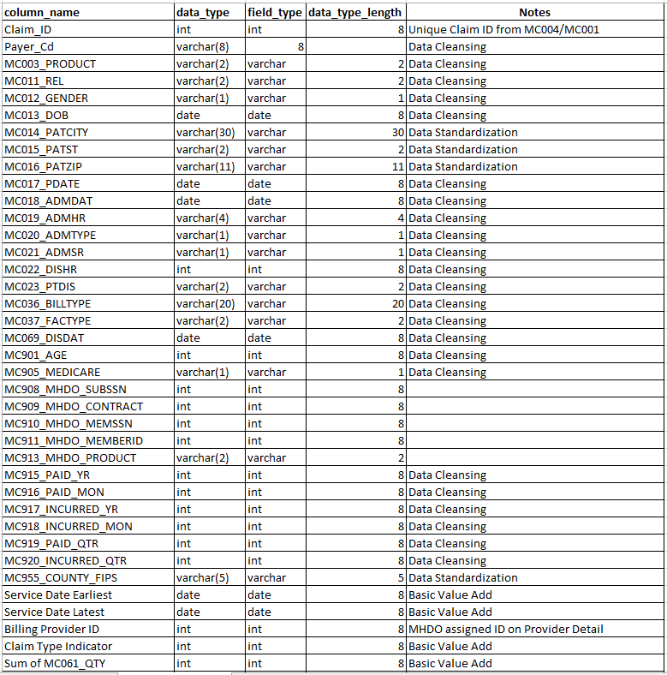
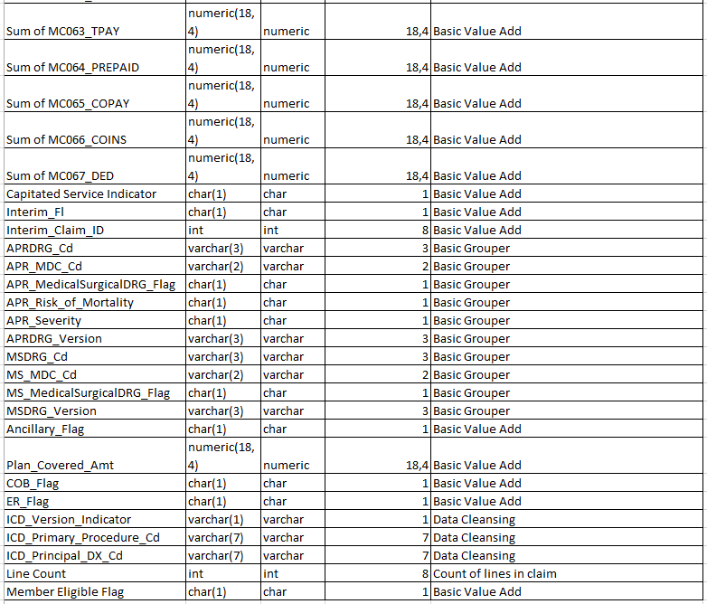

Medical Claim Line
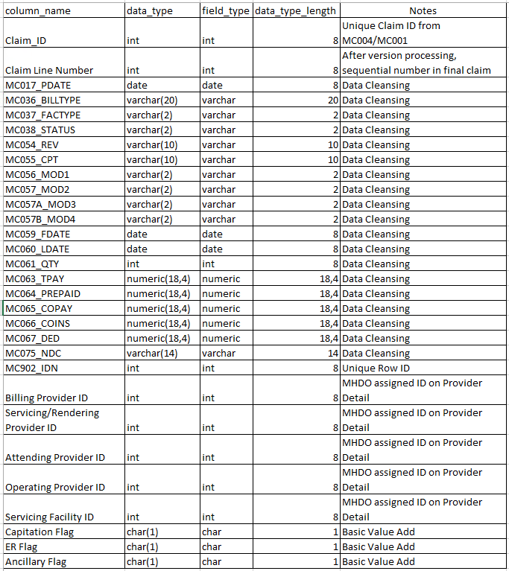

Provider File
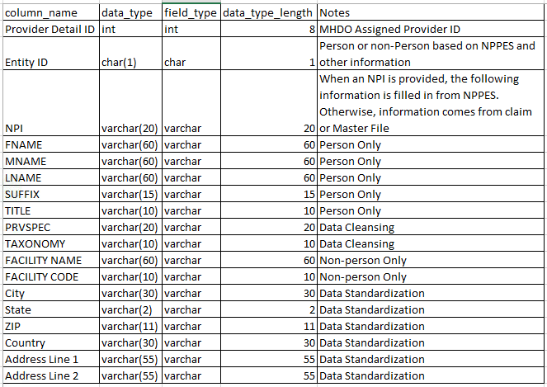

Medical Claim ICD Diagnosis Codes
Note that the principal diagnosis code will also appear on the claim header, for convenience.
The DX_Code_Type will indicate the type of diagnosis code (admitting, e-code, reason for visit, principal, or other). The sequence number will allow the relative position of e-codes, reason for visit, and other DX codes to be determined—it will be null for principal and admitting diagnoses.
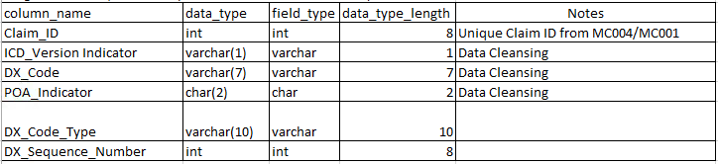

Medical Claim ICD Procedure Codes
Note that the principal procedure code will also appear on the claim header, for convenience.
The PX_Code_Type will indicate the type of diagnosis code (principal or other). The sequence number will allow the relative position of other PX codes to be determined—it will be null for principal procedure. Note that HCPCS and CPT codes do not appear on this table. They will appear only on the claim line detail data structure.
