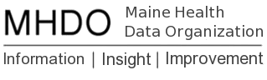

MHDO Super Data User Group Participants

APCD Subcommittee Participants

Name | Organization | Email
Roberta Gildart | EMHS | rgildart@emhs.org
Judy Loren | Compass Analytics | jloren@compass-inc.com
Deb Thayer | Muskie | dthayer@usm.maine.edu
Nina Underman | MaineHealth | NUNDERMAN@mainehealth.org
Gokhan Cakmakci | MaineHealth | gcakmakci@gmail.com
Becky Symes | MHMC | BSymes@mehmc.org

