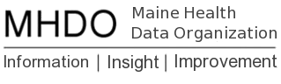

MHDO Super Data User Group Participants

Hospital Subcommittee Participants

Name | Organization | Email
Roberta Gildart | EMHS | rgildart@emhs.org
Cindy Mervis | CDC | Cindy.Mervis@maine.gov
Jayne Johann | Truven | jayne.johann@truvenhealth.com
Al Sheehy | MMC | SHEEHA@mmc.org
Lisa Parker | CDC | Lisa.Parker@maine.gov
Lara Rosen | MaineHealth | LRosen@mmc.org
Hilary Perrey | MaineHealth | HPerrey@mmc.org
Anne Ponsor | MaineHealth | APonsor@mmc.org
Chuck Flood | EMHS | ceflood@emhs.org

