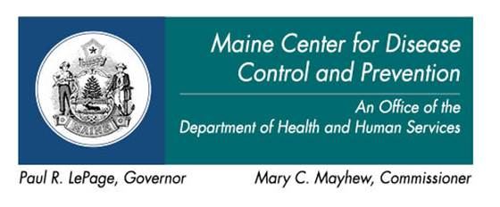 | 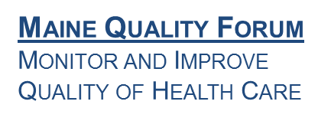

AGENDA

HAI Collaborating Partners Committee

Friday, Aug. 25, 2017  12:00 noon - 4:00 p.m. | Pine Tree Room  2 Anthony Avenue  Augusta, Maine  Or call: 877-455-0244  Conf. Code: 1546316229

Allergy Alert!
Due to a severe medical condition, all types of peanuts and tree nuts or foods, beverages and other products containing them are banned from the 2 Anthony Avenue building effective immediately. It is the expectation that all visitors will comply with this directive.
Please remember that 2 Anthony Avenue is a fragrance-free building.

12:00 – 12:10 pm Introductions and opening comments
Welcome new members and guests
12:10 – 12:20 pm Review of the minutes
12:20 – 12:40 pm Summary of new and pending HAI state legislation and
Council of State and Territorial Epidemiologists position statements
12:40 – 12:50 pm Progress report
12:50 – 1:50 pm Old business: Chapter 270
- Acute Care
- Nursing Home
- Dialysis
1:50 – 3:00 pm New business: Inter-facility communication
3:00 – 3:20 pm Public Comments
3:20 – 3:40 pm Meeting Evaluation
3:40 – 4:00 pm Next meeting and parking lot / adjournment

