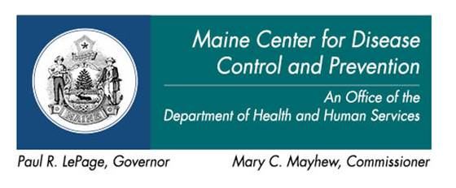

AGENDA
HAI Collaborating Partners Committee
Friday, September 25, 2015
1:00 p.m. - 3:00 p.m.
2 Anthony Avenue
Pine Tree Room
Augusta, Maine
888-387-8686, #3591279
FRAGRANCE FREE BUILDING
1:00 – 1:10 pm Introductions
1:10 – 1:15 pm Minutes of the July 2015 meeting [Attachment]
1:15 – 1:25 pm Quick update on the current status of the State HAI Plan
1:25 – 1:35 pm Ebola Readiness Assessment
1:35 – 1:55 pm Review Chapter 270 clean up changes
1:55 – 2:10 pm Preparatory introduction to more substantive Chapter 270 issues to discuss at the October meeting
2:10 – 2:30 pm Future meeting schedule
2:30 – 2:40 pm Public Comments
2:40 – 2:50 pm Preparation for next meeting
2:50 – 3:00 pm Meeting Evaluation

