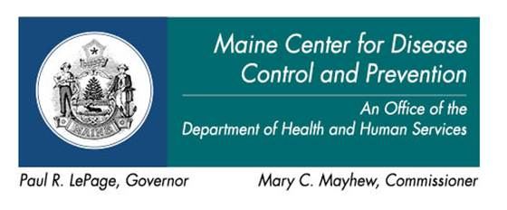 | 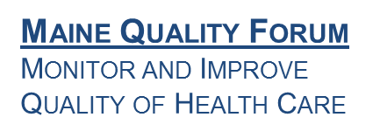

AGENDA

HAI Collaborating Partners Committee

Friday, January 22, 2016  12:00 noon - 4:00 p.m. | 2 Anthony Avenue  Augusta, Maine  PINE TREE ROOM  The building is Fragrance Free.  Or call: 888-387-8686, Conf. code 3591279
12:00 – 12:10 pm Introductions and Opening Comments
12:10 – 12:15 pm Minutes of the last meeting
12:15 – 12:45 pm Following-up from last Meeting and/or Updates
12:45 – 2:15pm Emerging Pathogens: Ebola Preparedness
- Report:
  - Ebola Readiness Assessments (ERA): Assessment Hospitals
- Discussion:
  - ERAs for non-assessment hospitals
  - Readiness sustainability for all hospitals
  - Emerging Threat Response Plan (Part I)
- Committee Recommendations
2:15 – 3:45pm Antimicrobial Stewardship (AMS)
- Report(s)
  - National Strategic Plan: Antibiotic Resistance
  - AMS surveillance programs – Acute Care
- Discussion(s)
  - AMS Plan for Maine
- Committee Recommendations
3:45 – 3:55 pm Public Comments
3:55 – 4:00 pm Meeting Evaluation/Adjournment

Meeting Materials:
HAI State Plan

