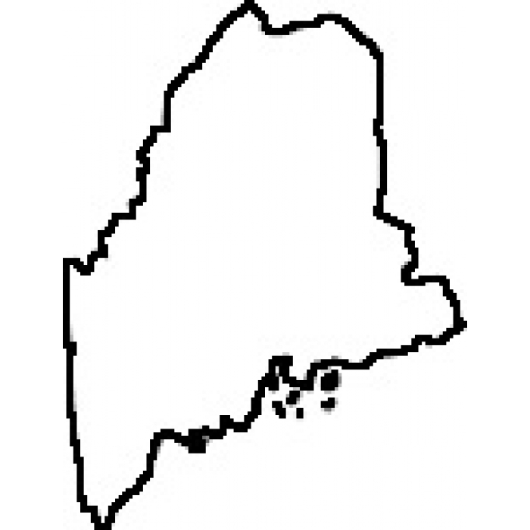
Maine HAI Plan
2016-2018
Introduction:
In response to the continuing concerns about the public health impact of healthcare-associated infections (HAI), the Maine Department of Health and Human Services (DHHS) Maine Center for Disease Control and Prevention (Maine CDC) and the Collaborative Partners state HAI advisory council have updated the Maine HAI Plan in order to outline improvement activities for the current year and next three years.

The initial focus for HAI prevention activities in Maine has primarily been on the acute care hospitals. Over the next three years, efforts will expand to be more inclusive of extended care and ambulatory care healthcare settings.

Purpose
Work across the continuum of healthcare settings to respond to outbreaks and emerging pathogen threats; analyze data in order to guide prevention activities; prevention future HAIs through collaborative and targeted improvement efforts
RESPOND
Detect, investigate, control and prevent HAI-related outbreaks
Ensure preparedness for emerging pathogens, especially those needing enhanced precautions

PREVENT
Provide education, training and consultative services
Engage in infection prevention activities
Expand antimicrobial stewardship efforts

ANALYZE
Prioritize HAI data for statewide surveillance
Ensure quality of data
Ensure surveillance data is available to key stakeholders
Increased data analysis

Metrics to Evaluate Success
Progress toward national Healthy People 2020 prevention targets.

RESPOND
Priorities | Year 0 (2015) | Year 1 (2016) | Year 2 (2017) | Year 3 (2018)
Detect, investigate, control and prevent  HAI-related outbreaks | Design and implement a system to track HAI outbreak response and outcomes, for outbreaks reported to public health. | Assess capacities of healthcare facilities to detect, report and respond to potential outbreaks and emerging threats.  Determine gaps in HAI outbreak reporting and response in all healthcare settings | Address gaps in outbreak investigation capacity by working with healthcare partners to develop a plan (and infrastructure) to improve outbreak reporting and response.
 |  | Explore the need for additional laws related to state authority for public health to conduct investigations related to HAI outbreaks and infection prevention. | Explore communication plans among healthcare facilities to minimize the risk of transmission of infectious disease and/or outbreak.
Ensure preparedness for emerging pathogens, especially those needing enhanced precautions | Assess Ebola readiness at all four Ebola-assessment hospitals in the state. DHHS to work collaboratively with these selected healthcare facilities to address any remaining gaps in readiness in order to achieve “capacity met” status in each of eleven domains of preparedness.
 | Finalize efforts to include  CRE on the ‘Notifiable Conditions’ list; so that all cases of CRE would be reportable to Maine CDC for epidemiological study. | Analyze initial data from CRE as a Notifiable Condition in the state. Based on first year findings, determine the need for additional guidance for control of CRE beyond the federal CDC 2012 CRE Toolkit. | Include CRE data in the Reportable Infectious Diseases in Maine annual summary report.

RESPOND
ANALYZE
Priorities | Year 0 (2015) | Year 1 (2016) | Year 2 (2017) | Year 3 (2018)
Prioritize HAI data for statewide surveillance | Review and revise state mandated HAI reporting requirements (Chapter 270) | Explore surveillance for LTC facilities, targeting MDROs, antibiotic usage, use of MHDO vs. NHSN for reporting.
Ensure quality of HAI data | Conduct data validation on MRSA, CAUTI and SSI. | Conduct data validation on  CDI, MRSA, CLABSI | Conduct data validation on  CDI, MRSA, SSI | Conduct data validation on CDI, MRSA, CAUTI
Ensure surveillance data is available to key stakeholders | Legislature and Public: State HAI Annual Report issued by MHDO/MQF.
 | Acute Care: CEO Dashboard Reports issued annually by Maine CDC; facility specific trend of HAI and prevention data.
Increase data analysis |  | Develop and implement the Data Analysis by Region for Trends (DART) Program.  Utilize data from infections, outbreaks, antibiotic resistance, etc. to identify geographic location in which to target assessment and prevention efforts.

PREVENT
Priorities | Year 0 (2015) | Year 1 (2016) | Year 2 (2017) | Year 3 (2018)
Provide education and training |  | Build resource list or library of various educational tools, presentations, etc. that have been created. Share repository with healthcare facilities in state. | Promote patient education ‘What you can do to help prevent infection’. Explore public service announcement, facebook, twitter, radio spots, newspaper, website, etc.
 |  | Explore logistics of holding a bi-annual HAI prevention conference.
 |  | Promote International Infection Prevention Week (APIC) – October
Explore requiring Infection Prevention and Control staffing capacity levels.
Explore requiring infection control and prevention competency as part of licensing or credentialing for providers.
Engage in infection prevention activities. |  | Develop and implement Infection Control Assessment and Promotion (ICAP) Program.  Based on data from the DART Program, perform targeted assessments in infection prevention and control competency in core domains at healthcare facilities. Identify gaps and work through the HAI advisory council for state/region mitigation planning.
Acute Care
Collaborative programs hosted by Healthcentric Advisors [QIN-QIO], to reduce HAIs related to CLABSI, CAUTI, CDI, and VAE.
CEO focus group hosted by MHA, to center attention on reduction of CDI and MRSA.
Expand antimicrobial stewardship efforts |  | Survey of healthcare facility AMS surveillance program – elements of program, etc. | Explore impact of antibiotic shortage issues on AMS recommendations.
 | MICIS??
 |  | Promote Get Smart About Antibiotics Week (CDC) – November
 |  | Roll out study with clinical laboratories to conduct DNA analysis on isolates of multidrug resistant organisms (e.g. MRSA, VRE, CRE and VISA) in order to determine the resistance genes most frequently seen in Maine. The next class of antibiotics will target these resistance genes in bacteria. | Share the findings with providers.

How are we doing?

