MHDO APCD Business Rules and Entity Relationship Diagrams (ERDs)
Last Updated: 10/17/2022
Introduction 2
Business Rules 2
Age 2
Enhanced MHDO Member, Person, Provider ID v2.0 2
Integer Substitution of Identifiers 4
Medical Claim Consolidation Table 4
Entity Relationship Diagrams (ERDs) 8
Key 8
Definitions 8
Medical Claims 9
Pharmacy Claims 12
Dental Claims 14
Eligibility 16

Introduction
This document is designed to provide background on MHDO’s APCD Business Rules and entity relationship diagrams for current and potential data users. This Business Rules were developed to describe the current methodology used to derive the value-added components of the MHDO APCD. The entity relationship diagrams (ERDs) were developed to show the relationships between data tables. This documentation will evolve over time as we continue to enhance the MHDO Data Warehouse and APCD capabilities. This will include the development of analysis ready datasets and the inclusion of more value adds (groupers).

Business Rules
The following describes the methodology used to derive the value-added components of the MHDO APCD.

Age
In the claims data, the age fields (MC901_AGE, PC901_AGE, DC901_AGE) are calculated based on date of service date (MC059_FDATE, DC035_FDATE) and member’s date of birth (MC013_DOB, PC013_DOB, DC014_DOB) or filled date (PC032_FDATE). In the eligibility data, the age fields (ME901_AGE, PE901_AGE, DE901_AGE) are calculated based on the fifteenth day of the eligibility month (ME005_MONTH, PE005_MONTH, DE005_MONTH) and the member’s date of birth (ME014_DOB, PE014_DOB, DE014_DOB).
The rule of top coding applies to patients ages 90 or older. A person that is 90 years old at date of service will have the age field set to value ‘90’ and the date of birth field set to missing. A person that is 91 years old or older at admission will have the age field set to value ‘90’ and the date of birth field set to missing.

Enhanced MHDO Member, Person, Provider ID v2.0
These enhanced deidentified MHDO-Assigned replacement IDs were created with the following design goals:
- To make assignments based upon the best identification information available at the time
- To prioritize the use of identifiers so that the quality of any matching is as high as possible while allowing for name and address changes, minor typos, etc.
- To implement quality standards to disallow or flag low-quality or “suspect” matches
- To eliminate the ambiguity created by using a single identifier that may only be valid within a specific contract or -payer (i.e., to establish a true member ID/person ID distinction)
- To create an identification scheme that can be shared by both the APCD and hospital encounter data systems
- To create a system that can leverage third-party patient information sources
- Ensure that MHDO-assigned member and person replacement identifiers do not disclose in any way personally identifiable information.

Enhanced Deidentified Member and Person ID
The enhanced deidentified MHDO-assigned replacement Member ID is unique for a given member within a given payer contract to the extent possible given the identifiers we receive from data submitters. Similarly, the enhanced deidentified MHDO-assigned replacement Person ID is unique for a given person regardless of payer or contract, subject to the same limitations. Thus, it is possible that one person ID will be associated with multiple member IDs over time. If an unambiguous member or person ID cannot be established due to ambiguous, conflicting, or missing data, no member or person ID will be assigned.
The previous MHDO-assigned Member ID only relied upon the contract number, member SSN, and/or the subscriber SSN in addition to the member gender and date of birth to make an identification. Thus, when only contract number was available, the original Member ID only identified a member within that contract. When the member or subscriber SSN was available, the original Member ID could identify individuals between payers and contracts.
The enhanced MHDO-assigned Person ID makes use of the full set of demographic information available in order to make a Person ID assignment. This includes member/subscriber name, address and patient control numbers. Thus, the enhanced Person ID can better identify persons between payers and across time.
The enhanced deidentified MHDO-assigned replacement member identifiers appear in the claims and eligibility data as DC975_Member_ID, DE975_Member_ID, MC975_Member_ID, ME975_Member_ID, PC975_Member_ID, and PE975_Member_ID. All of these fields will contain integer values.
The enhanced deidentified MHDO assigned replacement person identifiers appear in the claims and eligibility data as DC976_Person_ID, DE976_Person_ID, MC976_Person_ID, ME976_Person_ID, PC976_Person_ID, and PE976_Person_ID. All of these fields will contain integer values.

Provider ID
The enhanced MHDO-assigned replacement Provider ID is a single integer identifier that is assigned to a provider (regardless of whether that provider is acting as a rendering provider, an attending provider, etc.) on a given claim. Each MHDO assigned provider ID is associated with no more than one NPI. However, there are situations where no NPI could be associated with a given provider ID (less than 0.01% in claims data since 2018).
These enhanced MHDO-assigned replacement fields are: DC960_Servicing_Provider_ID, DC961_Billing_Provider_ID, DC962_ServiceFacility_ID, MC960_Rendering_Provider_ID, MC961_Billing_Provider_ID, MC962_ServiceFacility_ID, MC963_Attending_Provider_ID, MC964_Operating_Provider_ID, MC965_Referring_Provider_ID, PC960_Prescribing_Provider_ID, and PC961_Pharmacy_ID.
For data releases that include Provider Identifiable data as outlined in Chapter 120, the following enhanced fields will be provided: DC963_Servicing_Provider_NPI, DC964_Billing_Provider_NPI, DC965_ServiceFacility_NPI, MC966_Rendering_Provider_NPI, MC967_Billing_Provider_NPI, MC968_ServiceFacility_NPI, MC969_Attending_Provider_NPI, MC970_Operating_Provider_NPI, MC971_Referring_Provider_NPI, PC962_Prescribing_Provider_NPI, and PC963_Pharmacy_NPI.To support the enhanced MHDO-assigned replacement Provider ID, authorized data users will receive a new support table vwSupport_Provider_Details beginning with this release. The table will provide one row for each Provider ID with provider details as authorized under Chapter 120 for release, such as taxonomy code and, for data users authorized to receive provider identifiable information, provider name. A text file named vwSupport_Provider_Details_Layout with the layout of this new file will also be included in this release.

Integer Substitution of Identifiers
In order to reduce the size of data files and to enhance security, the MHDO performs “integer substitution” on certain fields. The process replaces the underlying value with a unique integer. The integer is not derived from the contents of the field, meaning that there is no way for data users to decode the integer into the original field value. However, every instance of a given field value will always be assigned the same integer, allowing for matching between records.
Integer substitution is performed on the payer’s claim ID, social security numbers, contract numbers, and MHDO-Assigned Member Numbers.

Medical Claim Consolidation Table
On occasion, data submitters send in revised claims or eligibility files to replace ones that have already been released. In the past, the MHDO has provided information about these resubmissions in the release notes so that recipients of past releases can adjust their analyses. The Medical Claim Consolidation Table has been adjusted to eliminate any of these resubmitted files. Thus, data users who join to this table will automatically have resubmitted files removed from their analyses. The MHDO intends to begin distributed lists of valid file IDs as a part of future data releases for all file types.
Based on feedback from MHDO data users we have developed and are releasing "Claim Consolidation" information for medical. This involves providing information on which claim lines should be included to form "the final version" of the claim. Delivering this level of information will allow data users to more quickly exclude claim lines that have been reversed or reissued. The APCD Release Report that accompanies each data release has been enhanced with new worksheets that make use of this consolidation information to only show statistics from the final version of the claim. These new worksheets are “MC PMPM Consolidated”, “MC Full Consolidated Pivot”, and “MC Consolidated Stats”.
The following snippet shows how the claim consolidation table can be used to restrict a medical claims table to only the final claim lines in SQL. The inner join causes only claim lines with an MC902_IDN value in the claim consolidation table to be returned.
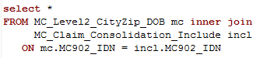
MaineCare and commercial payers occasionally issue adjustments or reversals to previously paid medical claims. Past analysis has shown that adjustments happen with less than 3% of the commercial claims and the claims that get reversed are more likely to get reversed multiple times. According to MHDO Rule Chapter 243 and the ASC X12 837 standard each version of the claim should be fully reversed before new claim lines are issued. However, of the top five commercial payers which represent approximately 80% of the commercial claims data, the MHDO is aware of one that is not able to do this. Aetna has provided the MHDO with their custom versioning logic which allows the MHDO to determine the final version of the claim in these cases. When there is payer-specific logic, MHDO will use it instead of the standard versioning method. By default, however, the version of the claim with the latest paid date will be considered the final version of the claim. The logic takes into account claim line-level information such as member, service date, and procedure codes to attempt to detect reversals that are issued under different claim numbers.
In some cases, the most recent version of a claim will be the reversal and the reissue of the new claim lines may have been issued under a new claim number. In these cases, the original claim will include both the initial bill and a set of reversals essentially "zeroing out" the claim.
So, for instance, claim 15434324 may have had an initial bill (IDNs 8841231-8841233), a reversal (IDNs 9268232-9268234), and a newly issued bill (IDNs 9854741-9854743). In this case, only the claim lines from the newly issued bill should be used.

Claim Consolidation Table Example
MC907_MHDO_Claim | MC902_IDN
15434324 | 9854741
15434324 | 9854742
15434324 | 9854743
15434325 | 56849847
15434325 | 56849848
15434325 | 56849849

In the above example, claim detail lines associated with two claims are shown: 15434324 and 15434325. Each of these claims has three claim detail lines associated with it. Performing an inner join of this table to the medical claims detail table on the MC902_IDN field will restrict the detail to only detail lines that in the final version of the claim.
As the MHDO receives new data, the set of "final claim lines" may change for a claim. The MHDO will distribute a full refresh of the Claim Consolidation table with every data release. This table should cover the full date range of your data request, including IDNs for both newly distributed data and data that have been previously sent. Users making use of this table will need to perform an inner join with the with the medical claims detail table with each data release since reversal activity can continue long after the initial payment of the claim, especially for high-dollar claims. As MHDO becomes aware of payer-specific issues that prevent the standard logic from operating correct, the MHDO will work with payers to implement custom consolidation logic.

Insurance Product Type Codes
The classification authority for claim product types and eligibility product types differ in Chapter 243, although the two sources use some of the same code values. In an effort to avoid confusion, the MHDO has historically recoded 4 of the most common claim product types (12, 13, 15, and 16) submitted in MC003 to use values that match the semantics of the eligibility (PR, PS, IN, and HN, respectively). This recoding is performed and released in MC913_MHDO_PRODUCT.

Geocoding-Related Fields
The following data elements included in the MHDO release file represent geocoded information and related metadata fields based on the patient address submitted to MHDO: FullFIPSTract, AccScore, AccType, fl_HighQualityGeo, fl_POBox.
All current and historical patient addresses are subject to an annual geocoding and data enhancement process using a third-party HIPAA-compliant tool, Geocodio, through which they are assigned geographic coordinates (Latitude and Longitude) and geographic identifiers such as Census tract ID.
The FullFIPSTract represents the 11-digit FIPS code for Census tract ID as of the 2020 Census year. The geocoding tool used also returns information about the quality of the match through the data elements AccScore and AccType, referring to accuracy score and type, respectively. For more detail about accuracy types and accuracy scores in the Geocodio output, please visit: https://www.geocod.io/guides/accuracy-types-scores/.
All original address observations submitted to MHDO that have a match among the geocoded address observations have a populated FullFIPSTract field in the release file, regardless of the accuracy of the geocoding output. Data users are cautioned to explore these additional metadata fields for the selection of high-quality geocoding matches.
Fl_HighQualityGeo and fl_POBox are additional input address quality and geocoding output quality flags created in the MHDO Data Warehouse.
Fl_POBox is a boolean (true/false) flag indicating whether the address has been determined to represent a PO Box address. As per relevant literature, it is important to keep track of the presence of PO Box addresses. They, at best, represent an approximation of the physical location of persons, and they should therefore not be treated the same way as precise addresses. Data users should be aware of PO Box volume in their analyses and make an informed decision about setting those aside or accounting for them in analyses. The logic used for creating this flag is applied to the street detail information and takes into account all possible spellings of PO Box (e.g, PO Box, P.O. Box, Post Office Box, Postal Box), including misspellings. This logic does not cover scenarios such as having just “box” but not “P.O.” in the address. The flag value will be set to ‘true’ for addresses such as “Post Road Box 100”, where “Post Road” is a street name; expected to be rare occurrences and they may represent a similar address type as PO Boxes.
Fl_HighQualityGeo is a boolean (true/false) flag indicating whether the address has been linked to a high-quality geocoding output. The flag will be set to ‘true’ if it meets the following conditions, concomitantly: (a) Input and output address information includes ZIP code and the input ZIP code is the same as the output ZIP code. (b) The Geocodio output Accuracy Type (AccType) is either ‘rooftop’ or ‘range_interpolation’. Excludes addresses with any other Accuracy Type. (c) The Geocodio output Accuracy Score (AccScore) is above 0.8. Excludes addresses with scores of 0.8 or lower, or with null values. Records that do not meet the (a), (b) and (c) criteria will have the flag set to ‘false’.

Recommended geocoding quality flag selection: Geographic identifiers such as FullFIPSTract have the highest reliability for records with fl_POBox = ‘false’ AND fl_HighQualityGeo = ‘true’, though a different address record selection may be acceptable depending on use case. For example, for analyses for county or regional geographic areas, including the PO Box addresses would likely be more appropriate, compared to analyses looking at more granular geographies such as the Census tract. Data users have the flexibility to start from exploring the fl_HighQualityGeo flag in conjunction with the source metadata fields AccScore, AccType and the fl_POBox flag, and implementing a custom record selection tailored to the specific analytic use case at hand.
Recommended geographical information use: Data users should monitor the percentage of records with PO Box addresses in their analyses and consider including a cautionary note informing report viewers about the respective percentage and that those addresses may be assigned a different Census tract ID than they would if they would represent the physical location of residence rather than the PO Box mailing address. While PO Box addresses exist in both rural and urban counties, it is likely that a higher share of these addresses are in rural counties. Depending on the type of analysis, data users may want to consider setting aside records with PO Box addresses from analyses.

Entity Relationship Diagrams (ERDs)
This diagram is slated to be updated with newly available information by the end of 2022.

Key
Primary Key
Foreign Key

Definitions
Primary Key: A primary key is a field (or collection of fields) in a table that uniquely identifies a row on that table.
Related Table: A table that contains data that can be linked to a particular table in question.
Foreign Key: A foreign key is a field (or collection of fields) in a table that uniquely links to a primary key in a related table.
Multiplicity Indicators: 0..1 means “zero to one” and 0...* means “zero or more”

Medical Claims

Diagram
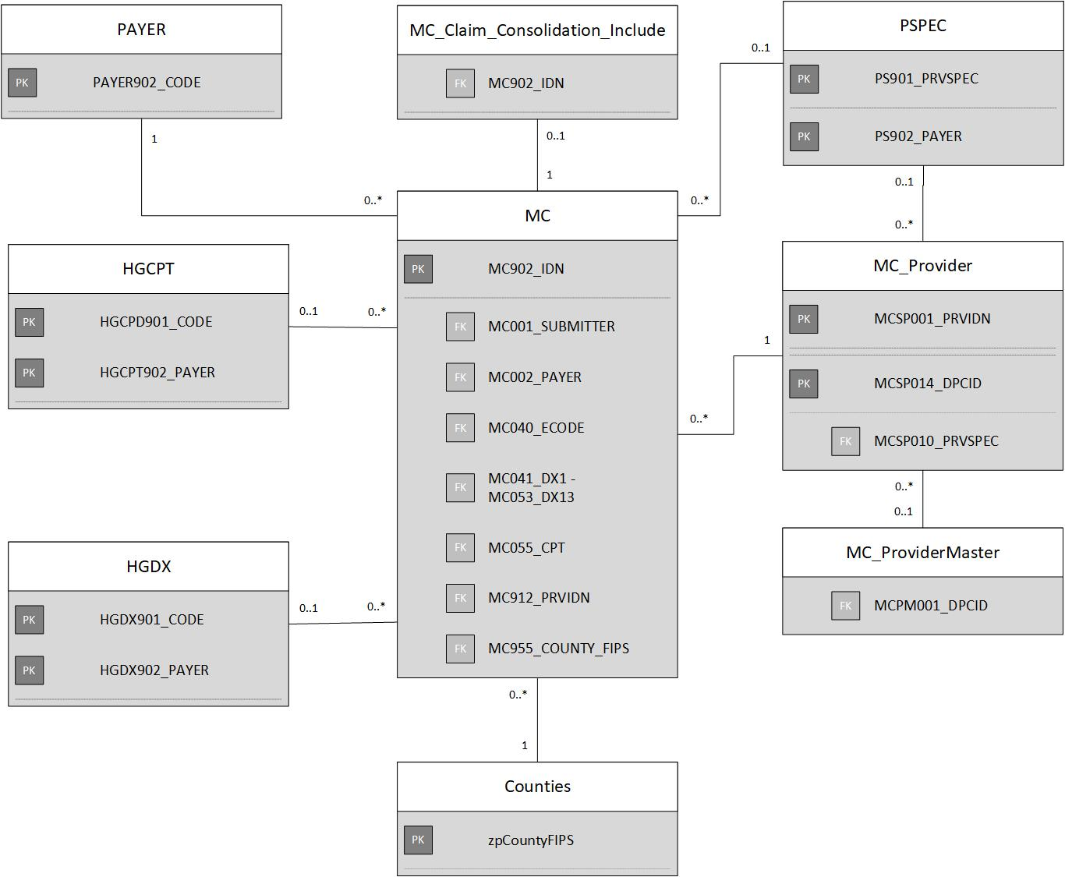

Support Table
Table Name | Table Description | Primary Key | Related Table Name | Related Table Description | Foreign Key
PAYER | Payer Code Support Table | PAYER902_CODE | MC | Medical Claims Release Table | MC001_SUBMITTER, MC002_PAYER
MC_Claim_Consolidation_Include | Medical Claims Consolidation Support Table | MC902_IDN | MC | Medical Claims Release Table | MC902_IDN
PSPEC | Payer Assigned Specialty Codes Support Table | PS902_PAYER | MC | Medical Claims Release Table | MC001_SUBMITTER
 |  | PS901_PRVSPEC | MC_Provider | Medical Claims Service Provider Support Table | MCSP010_PRVSPEC
MC_Provider | Medical Claims Service Provider Support Table | MCSP001_PRVIDN | MC | Medical Claims Release Table | MC912_PRVIDN
 |  | MCSP014_DPCID | MC_ ProviderMaster | Medical Claims Provider Master Support Table | MCPM001_DPCID
Counties | Counties Support Table | zpCountyFIPS | MC | Medical Claims Release Table | MC955_COUNTY_FIPS
HGDX | Local Diagnosis Codes Support Table | HGDX901_CODE | MC  (link to only one of the fields to the right) | Medical Claims Release Table | MC040_ECODE
 |  |  |  |  | MC041_DX1
 |  |  |  |  | MC042_DX2
 |  |  |  |  | MC043_DX3
 |  |  |  |  | MC044_DX4
 |  |  |  |  | MC045_DX5
 |  |  |  |  | MC046_DX6
 |  |  |  |  | MC047_DX7
 |  |  |  |  | MC048_DX8
 |  |  |  |  | MC049_DX9
 |  |  |  |  | MC050_DX10
 |  |  |  |  | MC051_DX11
 |  |  |  |  | MC052_DX12
 |  |  |  |  | MC053_DX13
 |  | HGDX902_PAYER | MC | Medical Claims Release Table | MC001_SUBMITTER
HGCPT | Local Procedure Codes Support Table | HGCPT901_CODE | MC | Medical Claims Release Table | MC055_CPT
 |  | HGCPT902_PAYER | MC | Medical Claims Release Table | MC001_SUBMITTER

Pharmacy Claims

Diagram
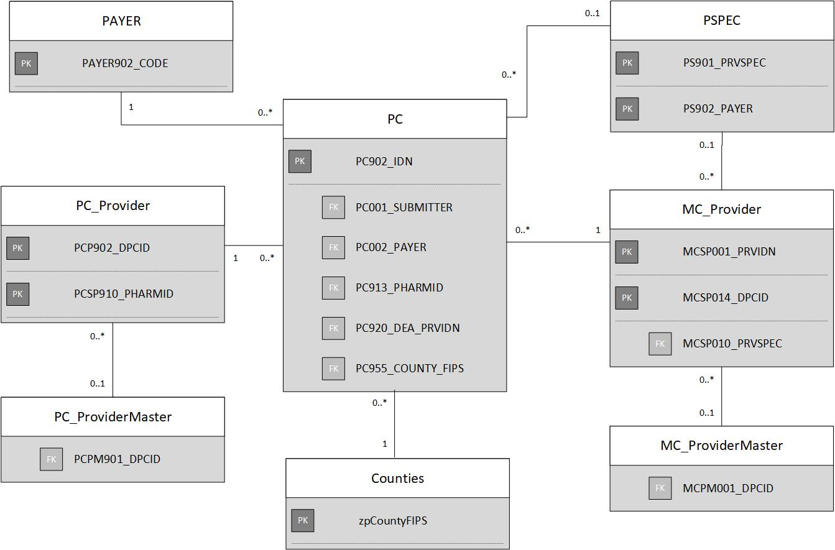

Support Table
Table | Table Description | Primary Key | Related Table Name | Related Table Description | Related Key
PAYER | Payer Code Support Table | PAYER902_CODE | PC | Pharmacy Claims Release Table | PC001_SUBMITTER,  PC002_PAYER
PSPEC | Payer Assigned Specialty Codes Support Table | PS902_PAYER | PC | Pharmacy Claims Release Table | PC001_SUBMITTER
 |  | PS901_PRVSPEC | MC_Provider | Medical Claims Service Provider Support Table | MCSP010_PRVSPEC
MC_Provider | Medical Claims Service Provider Support Table | MCSP001_PRVIDN | PC | Pharmacy Claims Release Table | PC920_DEA_PRVIDN
 |  | MCSP014_DPCID | MC_ ProviderMaster | Pharmacy Claims Provider Master Support Table | MCPM001_DPCID
Counties | Counties Support Table | zpCountyFIPS | PC | Pharmacy Claims Release Table | PC955_COUNTY_FIPS
PC_Provider | Pharmacy Claims Provider Support Table | PCSP910_PHARMID | PC | Pharmacy Claims Release Table | PC913_PHARMID
 |  | PCSP910_PHARMID | PC_ProviderMaster | Pharmacy Claims Provider Master Support Table | PCPM901_DPCID

Dental Claims

Diagram
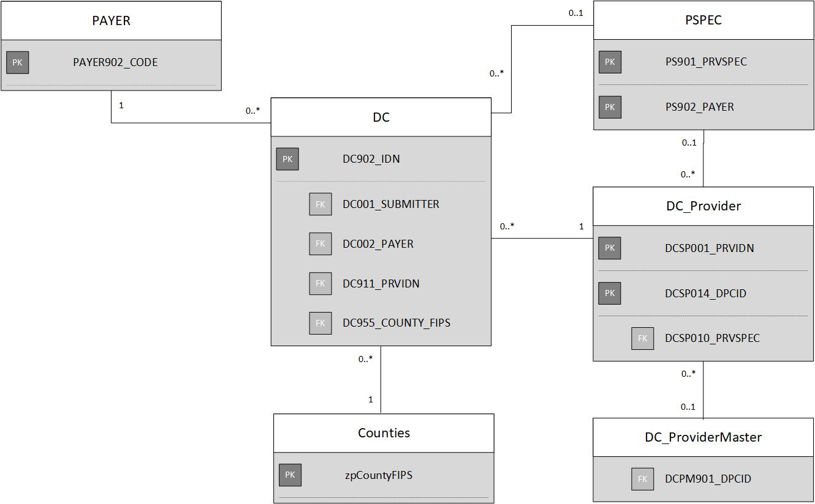

Support Table
Table | Table Description | Primary Key | Related Table Name | Related Table Description | Related Key
PAYER | Payer Code Support Table | PAYER902_CODE | DC | Dental Claims Release Table | DC001_SUBMITTER,  DC002_PAYER
PSPEC | Payer Assigned Specialty Codes Support Table | PS902_PAYER | DC | Dental Claims Release Table | DC001_SUBMITTER
 |  | PS901_PRVSPEC | DC_Provider | Dental Claims Service Provider Support Table | DCSP010_PRVSPEC
DC_Provider | Dental Claims Service Provider Support Table | DCSP001_PRVIDN | DC | Dental Claims Release Table | DC911_PRVIDN
 |  | DCSP014_DPCID | DC_ProviderMaster | Dental Claims Provider Master Support Table | DCPM901_DPCID
Counties | Counties Support Table | zpCountyFIPS | DC | Dental Claims Release Table | DC955_COUNTY_FIPS

Eligibility

Diagram
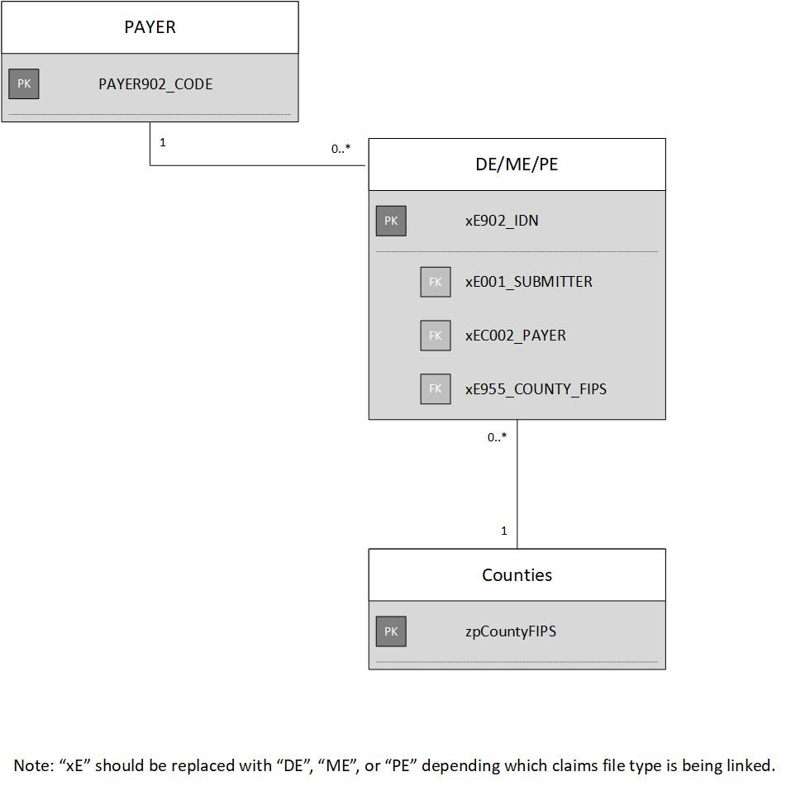

Support Table
Table | Table Description | Primary Key | Related Table Name | Related Table Description | Related Key
PAYER | Payer Code Support Table | PAYER902_CODE | DE/ME/PE | Eligibility Release Table | xE001_SUBMITTER,  xE001_PAYER
Counties | Counties Support Table | zpCountyFIPS | DE/ME/PE | Eligibility Release Table | xE955_COUNTY_FIPS

